District and County Councillor’s Report – September 2025

Local Government Reorganisation

The process, as requested by central Government, to merge District and County Councils into Unitary Authorities in England, is proceeding. The latest is that all local authorities in Cambridgeshire will have to submit their suggestions for how best they see a new local government structure working in the county.
There were originally 3 proposals on the table, which are outlined below:

Option A:
- South Cambridgeshire, Cambridge City & East Cambridgeshire.
- Fenland, Huntingdonshire & Peterborough.

Option B:
- South Cambridgeshire & Cambridge City.
- East Cambridgeshire, Huntingdonshire, Fenland & Peterborough.

Option C:
- South Cambridgeshire, Cambridge City & Huntingdonshire.
- Fenland, Peterborough & East Cambridgeshire.

We then had a late submission, spearheaded by the MP’s in Peterborough, for a fourth option:

Option D:
- An expanded Peterborough.
- Fenland, East Cambridgeshire, Huntingdonshire, South Cambridgeshire & Cambridge City.

The local views are that the District Council’s preference is Option B, which would leave us in an administrative partnership with Cambridge City only. This is largely what currently happens, with many services already shared between the two authorities.
Ultimately, central government will make the final decision so the business cases being drawn up will be highly important to influencing this decision.
The current timeline on this is:
November 2025 – Councils need to submit their preference and the corresponding business case to government
May 2026 – District Council elections take place, on the current local authority boundaries
May 2027 – Elections for the new ‘shadow’ unitary authority take place
May 2028 – The new unitary authorities come into power

Kingsway Solar Farm
The applicants of a new solar farm in the vicinities of West Wratting, Weston Coville and Carlton are pressing ahead with their proposals. The current step is that the applicants, Kingsway Solar, have released some actual detail (not just lines drawn around fields on a map) into the public domain. This detail is currently being publicly consulted upon via a process called a ‘Formal Consultation’. This is a very important stage of the process as the responses to this will form a part of the planning application which is submitted to a planning inspector. We would strongly advise everyone to engage with this consultation, as this potential development will affect us all in some way, regardless of proximity to the solar sites. The consultation opened on September 17th and will run until October 29th.
All of the documents can be viewed on the Kingsway Solar website - https://kingswaysolarfarm.co.uk/
There are also some open events, arranged and run by Kingsway, throughout October at various locations. Details of these are below:
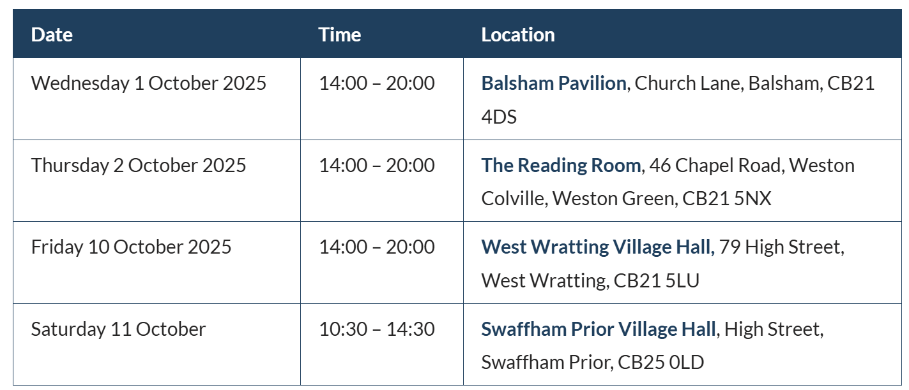

Kingsway have also indicated that they are due to begin some preliminary archaeological surveys (digging trial trenches) in some of the fields where solar panels are proposed. If anyone sees or reports this kind of activity, it’s very likely to be this.

Acorn Biodigester
For those that were following the progress of this planning application for an anaerobic digestion plant just outside of Haverhill, you may recall that Suffolk County Council refused the application in June this year.
The applicants, Acorn, have now indicated that they are planning to appeal this decision and have instructed their planning agents to do this. So, we can expect this to resurface in the coming months. Watch this space.

Council Tax Consultation
The District Council are currently consulting on the Council Tax Support Scheme for the 2026/27 financial year. It’s an opportunity for anyone to give their views on the working age section of the scheme. This specifically looks at levels of discount available to various groups who receive support. The consultation is open now and will run until October 15th.
https://engage.scambs.gov.uk/en-GB/projects/council-tax-support-scheme-26-27-consultation

Grants
There are a raft of community-focussed grants available via the District and County Councils. Rather than list them all here, they can be seen on their respective websites:
Distirct Council - https://scambs.gov.uk/grants-and-funding
County Council - https://www.cambridgeshire.gov.uk/council/communities/communities-service/community-service-small-grants

Contact Details
District Council – Geoff Harvey – geoff.harvey@gmail.com
County Council – Henry Batchelor – henrybatchelor89@gmail.com

