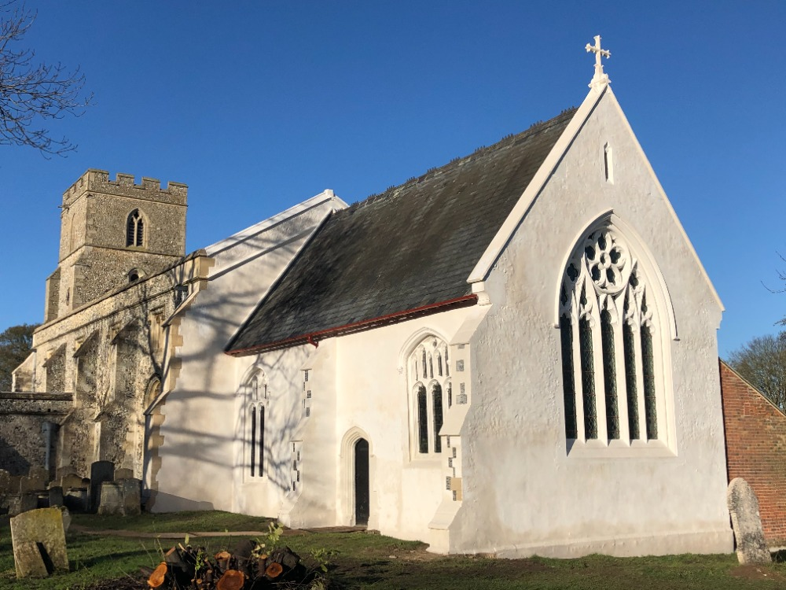

**Jubilee Church Service  
St Andrew’s Church, West Wratting   
10.30am, Sunday June 5th**

We will toast the Queen’s 70 years on the throne and sing the national anthem together.

The church will also be giving children in the village a gift of a hand-inscribed souvenir Bible to mark the Platinum Jubilee.

**All Welcome**