**Annual Report**

**St Andrew’s West Wratting**

**For the year 2017**

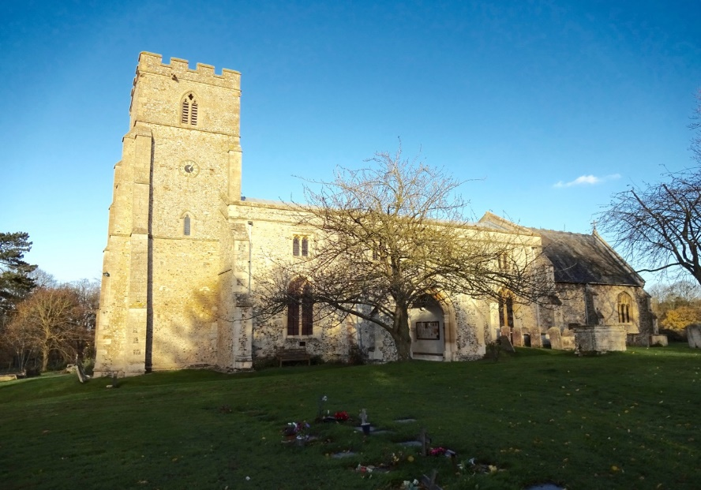

**Annual Meeting**

**27th March 2018**

**7.00 pm**

**St Andrew’s Parish Church, West Wratting**

### St Andrew’s Church, West Wratting– Annual Report of the Parochial Church Council for the Year Ended 31 December 2017

#### Administrative information

St Andrew’s Church in West Wratting is part of the Diocese of Ely within the Church of England. The correspondence address is 25, High Street, West Wratting CB21 5LU.

The Parochial Church Council (PCC) is a charity excepted from registration with the Charity Commission.

PCC Members who have served from 1 January 2017 until the Annual Church Meeting in 2017 are:

*Honorary Associate Priest*: Very Revd Keith Johnson

*Warden:* Prof Alexandra Walsham

*Warden*: Mr Sebastian Bain

*Secretary*: Mrs Linda Gorman

*Representative on the Deanery Synod*:

Mrs Jeanette Job

*Elected Members*: Mrs Jeanette Job (Ass’t Church Warden)

Mr Simon Sampson

Mrs Catherine Willcocks (Ass’t Church Warden)

Treasurer: Mr Gary Birditt

#### Structure, governance and management

The method of appointment of PCC members is set out in the Church Representation Rules. All Church attendees are encouraged to register on the Electoral Roll and stand for election to the PCC.

#### Objectives and activities

St Andrew’s Church, West Wratting PCC has the responsibility of cooperating with the Priest in Charge in promoting in the ecclesiastical parish the whole mission of the Church, pastoral, evangelistic, social and ecumenical. It also has maintenance responsibilities for the Church building, churchyard and surrounding areas bounded by St Andrew’s, West Wratting.

#### Achievements and performance

#### Church attendance

There are 29 parishioners on the Church Electoral Roll. The average weekly attendance in 2017 was 13 adults. This number increased significantly at festivals and the four Songs of Praise services held each year, some of which attracted as many as 90 people. Other services that were well attended were the Christingle, Carol service and the Crib service held on Christmas Eve at 4.00pm. We held a joint Christmas day service when we welcomed the parishioners of Weston Colville.

#### Review of the year. The Secretary’s report of the PCC

The PCC met 7 times during the year including one joint meeting with the group of seven churches in the Benefice. The main subjects of discussion were the upkeep of the fabric of the church, repair of the Nave roof after the theft of the lead and the process of appointing a New Priest to the 6 parishes that we are jointly combined with.

The members of the Standing Committee during the year were Linda Gorman, Alex Walsham, Jeanette Job, Catherine Willcocks, Sebastian Bain and Simon Sampson.

The pattern of regular worship during the year was unchanged. Communion services are held on all Sundays other than when we celebrate with members of all ages in a “Songs of Praise” service four or five times year. A Communion service on the fifth Sunday of the month was shared with parishes in the Abingtons, Weston Colville and ourselves. This pattern was sustained thanks to the careful stewardship throughout the year of Very Revd Keith Johnson (retired), Revd Kathy Bishop (Associate Priest), Revd Dr Carrie Pemberton-Ford, The Ven Alex Hughes, Revd John Pinder, The Rev Simon Talbott and Rev Monica Cameron.

We are grateful to Mrs J Romanis for her most valued contribution to St Andrew’s services as our Organist. We thank her sincerely for her dedication.

**Electoral Roll**

The Electoral Roll stands at 29.

**The Church Wardens Report**

The past year has been a busy one for St Andrew’s. The year has been dominated by the roof repair and the redecoration of the church following the lead theft, a process that has been costly and time-consuming. We have also undertaken a major reorganisation of the back of the church in order to facilitate wider and more flexible use of the space. This involved lowering the raised platform beneath the pews. The church has now been restored to its former glory. The churchwardens would like to thank all of those who have offered financial and practical support throughout this process, especially Di Edwards and Catherine Willcocks for their excellent work on the funding applications, Mark Addley for helping to project manage the roof repair, and Phil O’Donovan and Clive and Joanna Parry for their continuing support in many ways. We are also very grateful to our architect Ashley Courtney for overseeing the repairs and refurbishment of the church, together with the rearrangement of space and removal of pews at the back of the church. His dedication and commitment to St Andrew’s, well beyond the call of duty, is greatly appreciated.

Over the last year we have also been involved in the search for a new rector-designate for the Granta Vale benefice. The selection process took place in December and the churchwardens thank those who gave up time to welcome the candidates on a cold day and to make them feel welcome in West Wratting, as well as those who helped to draw up the benefice and parish profile. Our particular thanks go to Andrew Westwood-Bate, churchwarden of Hildersham for coordinating this process with much efficiency and wisdom. We greatly look forward to the arrival of Ian McColl and his family and to his licensing on 12 April 2018 at Balsham. Ian joins us from a curacy in Bristol, following a ten-year career as a solicitor. He trained for ordination at Westcott House in Cambridge so knows the area well. St Andrew’s is delighted to have a new priest after two years vacancy. As above, we thank Keith Johnson and Kathy Bishop, and other clergy who provided services during the interregnum and supported us through this period, together with the Archdeacon, Alex Hughes, and the Rural Dean, Simon Talbot.

In the course of the year, the Diocese of Ely undertook a review of its clergy housing and the decision was made to sell the West Wratting Vicarage in order to facilitate the purchase of property elsewhere in the region. The sale was delayed by the diocese in consideration of the challenges the parish has recently faced but the property has now been marketed and is under offer.

During the course of the year, various other activities have taken place. A summer barbecue was held in the churchyard in June, and we thank Scilla Harvey, Catherine Willcocks Sherry O’Donovan for their help with this. A fundraising clay shoot was held in August, and we thank Simon Sampson for organising this once again. The usual autumn concert in Balsham had to be delayed but it is hoped that it will be scheduled in the coming year. We have a commitment from Trinity College choir to do a concert in St Andrew’s in spring 2019.

In February 2018 we held the first ‘café church’ in St Andrew’s. This informal service involved children’s craft activities and an interesting and informative talk by Rob Loe on ‘relational education’, accompanied by tea and coffee and cakes. Around 27 people including 7 children attended. Catherine Willcocks is gratefully acknowledged for her energy and commitment in bringing this new initiative to fruition. Once again we owe thanks to Scilla and John Harvey for helping this to get off to an excellent start. Café church will be held at regular intervals throughout the year, with the next one planned for 29th April.

In recent months a St Andrew’s Support Group has been set up, led by Phil O’Donovan. We are immensely grateful to Phil for initiating this and providing leadership at its meetings, as well as to those who have attended and lent practical and moral support to this new enterprise, which will assist with specific fund-raising projects to ensure that St Andrew’s remains at the heart of the West Wratting community. The most significant of these projects is the provision of disabled access and toilet facilities. A visit by the DAC in February, in which representatives of both the PCC and Support Group were involved, was helpful in considering the most cost effective and practical way of achieving this.

We thank Keith Johnson and Kathy Bishop who, between them, have taken most of the services in West Wratting. Thanks also must go to The Archdeacon, Alex Hughes, who has been very involved in finding us replacement clergy, and has taken services; to the Rev Simon Talbott as our Rural Dean for his support and guidance; and to Canon John Pinder.

For the popular Songs of Praise we extend our thanks to John and Scilla Harvey for leading and arranging the services which we have held for the last few years – the team that supports the service is a key to its continuing success – many thanks to them, in particular the music team who have been drawn from Rock Baptist Church, Linton Free Church and Christ Church Trumpington, all of which have provided musicians. We are very grateful to Jeanette and Nigel Job for generously purchasing an electric piano for use during these and other services. Keith Day provided advice, helped to choose an appropriate instrument, and made a further donation.

Our sincere thanks are also extended to Cazzy Walshe. Our journey during the interregnum has been made so much easier and calmer due to her unfailing attention to the 7 churches within the group. The last few months have been more demanding than ever, with the additional work for arranging officiating clergy for all the services, ensuring diaries can be met, producing the orders of service specifically for us the Carol services and Christmas day Service. All these tasks have been completed in a most professional way. We would be in a very sorry state without Cazzy’s commitment and extend our sincere thanks to her.

St Andrew’s faces ongoing challenges, especially financial ones. The significant costs of the roof repair and redecoration, which involved unforeseen expenses, have eaten into our reserves at a time when the parish share and other daily running costs have increased, and in which other maintenance and fabric issues need to be addressed. In the coming year, it will be vital to redouble our regular fund raising efforts and to seek a review of regular giving through covenants. We are grateful to all those who support the church in many ways, including those who are not churchgoers, including Gary Birditt as our Treasurer. The day to day running of the church relies on an increasingly small group of people, whose ongoing commitment and capacity to provide assistance cannot be taken for granted. We need to plan for the future in terms of the succession of office holders and we are particularly keen to increase the membership of the PCC.

**Alex Walsham and Sebastian Bain**

**Church Wardens**

#### Financial review and Treasurer’s report

**General Fund**

Voluntary income from gift aid donations increased to £11,635 from £10,742 in 2016. This increase included some very welcome additional gifts. If we have written confirmation from individuals that they are tax payers we are able to recover 25% of the gifts given – this additional income is extremely important to us being over £6,395 for the past two years.

Monthly Covenant giving during the year amounted to £6,065 compared to last year’s £7,180 a reduction of £1,115 ( 15.5%). Covenants are the mainstay of our income and ensures we have a regular monthly cashflow to cover our outgoings – sincere thanks to those of you that support us in this way, this is truly appreciated.

Income from weddings and funerals were slightly lower than 2016 at £2,450. Total income for the year increased by 4.7% to £17,537 (last year £16,746).

General fund expenses increased by £379 (£684) to £12,212 from £11,833 last year (+3.2%). The parish share was paid in full which increased from £8,422 to £8,828 in the year ending December 2017 (4.6%).

General Funds increased slightly during the year end from £15,678 to £18,181.

**Restricted Fund**

The fund-raising events raised £2,530 during the year, compared to £4,323 last year. The Clay Pigeon shoot was the only significant event during 2017 and raised £2,530 compared with £2,770.

We must look in 2018 to holding more events if we are to maintain the upkeep of the church fabric.

The exceptionally successful fundraising for the roof repair, decoration, re-furbishment of windows, lowering the floor during the last two years is summarised as follows:

|  |  |
| --- | --- |
| Insurance claim | £15,000 |
| AS Charitable Trust | £6,000 |
| Wadlow Wind Farm | £10,000 |
| Nias Wheatley Trust  Amey | £2,000  £40,000 |
| Personal donations | £36,117 |
|  |  |
| **Total** | **£109,117** |

We took the opportunity of an interest free Loan of £20,000 from the Cambridge Historic Churches Trust, which we appreciate and thank them for. This loan is repayable over 4 years with 4 equal payments in April each Year. (at the time of writing the General fund has repaid the first instalment of £5,000).

The total cost of all the works in 2016 and 2017 amounted to £138,249.

The Restricted funds reduced during the year end from £106,749 to £5,001 which was transferred from current account to pay the first instalment of the loan.

We are very indebted to the many individuals who have so generously donated to our urgent repair needs and to the Grants received from Cambridgeshire Community Foundation Wadlow Wind Farm, Amey Community Fund, Cambridgeshire Historic Churches Fund, NIAS Wheatley Charitable Trust and the AS Charitable Trust without whose support we would not have been able to carry out the various projects highlighted elsewhere in this report.

**Gary Birditt**

**Treasurer**

**Reports of the PCC**

**Family Services 2017**

**Songs of Praise** - During the year four Song of Praise services have been held. An important aim in holding these services has been to attract families from the village, especially those who don’t regularly attend church. The numbers have typically been in excess of 70 and a very high proportion of those attending have come from the local village community. For each service a lively contemporary format has been followed with the music being led by a group drawn from Rock Baptist Church in Cambridge and Linton Free Church. These services have been kept child-friendly and young people have been encouraged to participate by doing readings, singing and engaging in the service in other ways. A short talk has been included, each time aimed at the children, but intended to be equally relevant to adults. June’s service was followed by a BBQ for the village and was enjoyed by all. October’s service concentrated on the Harvest, and was accompanied by a bonfire in which baked potatoes and bananas and chocolate were cooked. We thank Clive and Joanna Parry for initiating and organising this. In December, Songs of Praise took the form of a Christingle service when 90 attended. These Songs of Praise services have been well publicised including a leaflet distribution to houses in the village and at all of them there has been a very good community feeling with the congregation staying on to chat over tea and cakes afterwards.

**John & Scilla Harvey**

**Easter, Crib Service and other Christmas Services** – Many local families attend the Easter, Crib Service, Carol Service and other Christmas Services. Local children participate by doing readings and helping prepare the crib.

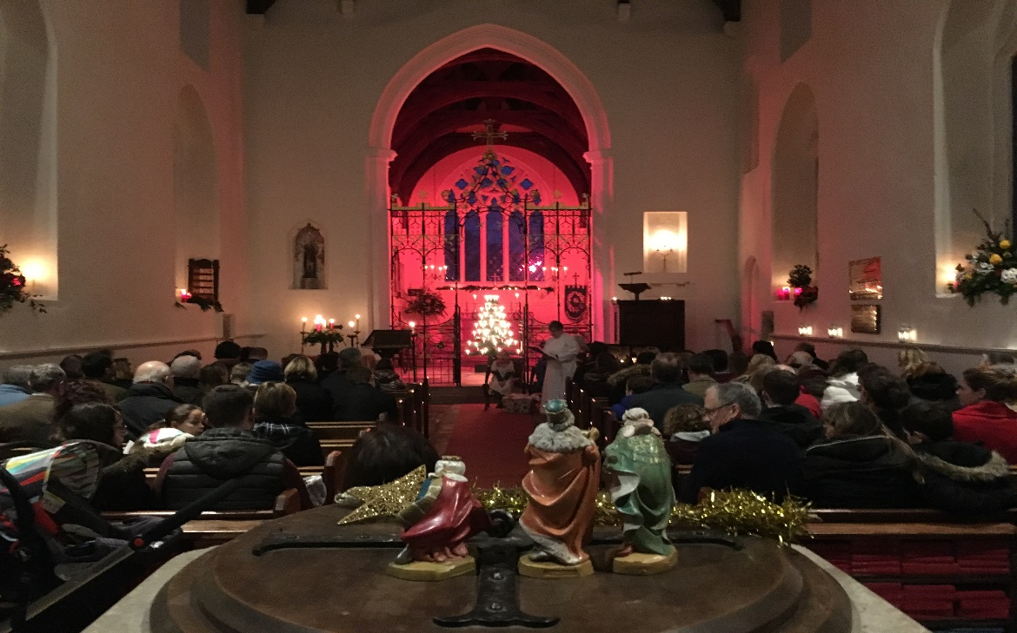

**Café Church** - This is a new venture in St Andrews West Wratting for 2018, The first of which will be held on Sun 11 Feb from 3-4, with further occasional services planned throughout the year. It is aiming to be an informal service, held around small tables and chairs at the back of the church, and starting in a relaxed way with coffee, tea and cake. There will be some music and prayer, and then a short talk with time for questions and discussion. It's going to be for all-ages, so activities will be provided for the children too. Everyone is welcome!

**Family-friendly Church Area** - The rearranged space at the back of the church and removal of the pews from this area has allowed a cosy family area, including comfortable seating and children’s play area to be created. This has proven invaluable during the regular services as well as family services. There are now also small tables and chairs in the area to allow refreshments after the service to be enjoyed by all. We are also seeing villagers and visitors to the church enjoying this space outside of the regular services as our church is kept open during daylight hours.

**Bell Ringing Report for the year 2017**

I am happy to report that the St Andrew’s band is in a steady state. Thursday evening practice nights continue to be well attended, with emphasis on consolidating the basics.  The band members are committed to Sunday service ringing and, increasingly, we have been able to cover most services. We have had no need of repairs in 2017.

**Mike Rowland**

**Tower Captain**

**Charities supported during the year**

We have supported Children in Need, the Royal British Legion, as well as raising £330 for the Tearfund.

**Fabric Report**

#### St Andrew’s Churchyard

The churchyard has been well maintained throughout the year. We had the usual Autumn and Spring clear-ups, and it is extraordinary how much can be achieved in 4 hours each time. Scilla Harvey is looking after the garden by the North of the church and Sherry O'Donovan has undertaken the maintenance of the garden to the South of the church. Both gardens look splendid, and it is always exciting to see what new plants and bulbs have been added.

We have lifted the canopies on 6 oaks and beeches that were planted by Brian Langford and myself about 17 years ago. The purpose being to have the benefit of the trees and the beautiful views of the countryside surrounding the church.

The damsons to the East of the churchyard have been taken down as they were becoming dangerous, thereby enabling 50/100 damson saplings to come through. These will be thinned in the years to come.

At the same time, the nearby hawthorn has been pollarded and tidied up.

We have identified two more self-sown cherries in the churchyard, and we are allowing these to grow.

The O'Donovans have kindly cut back the hazel on their side of the ditch to the South, thereby enabling the oak planted by Brenda Gethin in memory of her husband to grow upwards rather than outwards.

Suzanne Langford was kindly granted permission by the PCC to plant 750 daffodils at the most easterly point of the churchyard in memory of her husband Brian and son Tony. She press-ganged her family to plant the bulbs, and they are now beginning to flower at the time of writing, and will be a huge enhancement and a fitting memorial for years to come. Thank you, Suzanne, for your generosity.

Meanwhile, the large cherry tree to the South of the church and to the East of the porch is slowly dying, in spite of some gentle pollarding, and there are ominous signs of branches falling off the ash next to it. An eye will have to be kept on both.

Many, many thanks to everyone who turns up to the bi-annual clear-ups, and the regulars who keep everything in such good condition during the growing season - Pete Rendall, Ben Willcocks, Simon Chandler, Simon Sampson, Kevin Brown and Andrew Waygood.

Our churchyard remains a beautiful part of West Wratting, and is heartening to see both church goers and non-church goers rubbing shoulders together to keep it that way.

**Cobby McCall**

**The Church housekeeping**

Suzanne Langford has continued to polish the brasses, which sparkled, come rain or shine, and has made other generous donations. We remain grateful to her and to all who clean the church, especially Frances Peers, Jenny Knowelden, Sue Lock, Maggie Attewell and Pauline Holness, as well as to the flower arrangers whose displays beautify the church: Frances Peers, Alex Walsham, Jenny Knowelden, Louise Sampson and Linda Gorman.

Also, thank you to Ben Willcocks for looking after the central heating and the electrics, and Di Edwards for maintaining the fire extinguishers and arranging other maintenance tasks. We thank Mark Addley for looking after the roof gutters and the clock.

Suzanne very kindly donated the Christmas tree, which was erected and decorated by Ben Willcocks, Jenny Knowleden and Alex Walsham.

Thanks to Linda Gorman, Catherine Willcocks, Scilla Harvey and Sherry O’Donovan for coordinating a working party to clean the kitchen and discarded broken, unwanted and superfluous items, and to those who came to help. We are grateful to Catherine and Ben Willcocks for donating new mugs and to Sherry O’Donovan for purchasing new fold up tables. We thank the Village Hall for the long-term loan of several trestle tables, which have now been returned.

The coffee and biscuits after the service are always a welcome time for us to chat and catch up on the week’s events – sincere thanks to everyone that supports this social part of the Service.

Since October 2009 the church has been kept open during daylight hours for visitors to appreciate St Andrew’s. Many thanks to Sisse McCall for managing the rota and opening up since we started and Sherry O’Donovan, Louise Sampson, Pamela Richardson, Margaret Potter, Maria and Kevin Brown, Lynne Davidson for coming whatever the weather to open up early in the morning and late in the evening.

**The Roof and internal Redecorations**

Significant lead theft of the nave roof took place in April 2016 putting the fabric of the church at considerable risk. Volunteers and a local contractor did their best to provide temporary roof coverings until permanent repairs could take place, butunfortunately water still got in in places and spoilt the wall finishes.

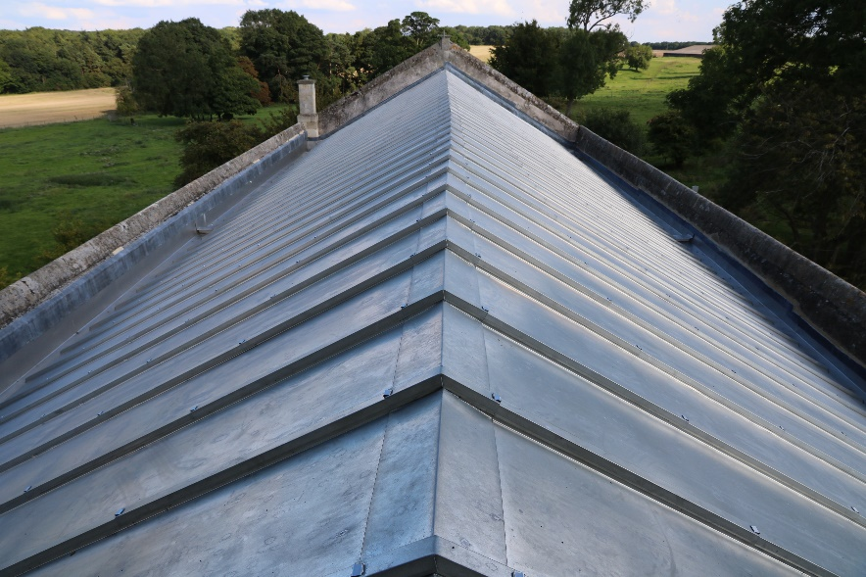

Regrettably the cost to replace the roof in lead again would have been too great and would not prevent the risk of theft again so it was decided to replace the roof covering in terne-coated stainless steel. This was carried out by Bakers of Danbury, in the first half of the year. Two notices indicating that the roof is now covered with stainless steel have been erected as a further precaution.

Our attention then turned to redecorating the nave for which we had to scaffold the whole of the interior. We also took the decision to redecorate the chancel at the same time. In undertaking this work we restored, so far as reasonably practicable, the classical mouldings in the chancel. These mouldings were the vestiges of a classical scheme that went throughout the church and was installed in 1737, but was almost comprehensively removed in the late C19 when the church was re-gothicised; the remaining mouldings had been filled in. We also decided to remove some of the cementitious render at the west end of the church, west of the doorways. A volunteer party from within the village helped to remove the incredibly hard cement one Saturday, and we then had Philip Gaches, a master plasterer, re-renderthe walls in hot lime mortar - this will be a huge benefit to the church in reducing the amount of damp being driven up the walls.

During the course of the preparations to limewash the interior we discovered some medieval graffiti on the chancel arch, the most exciting image being a drawing of a knight! We were also concerned about finding any remaining medieval paint schemes so we employed the services of a specialist conservator, Andrea Kirkham, to have a thorough look. In the event she did not find any medieval paint except for some traces in the niche on the north side of the chancel arch. We hope to have her back to clean this area up more carefully once funds allow.

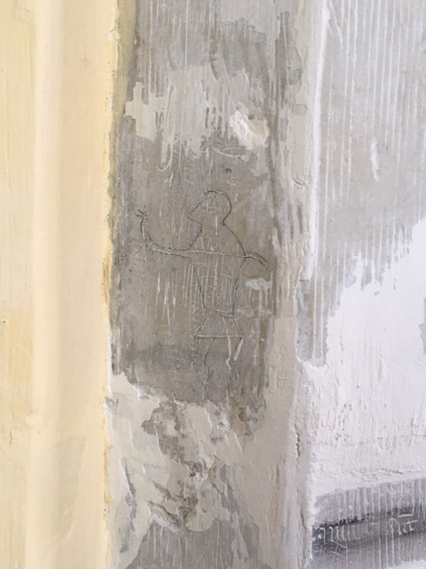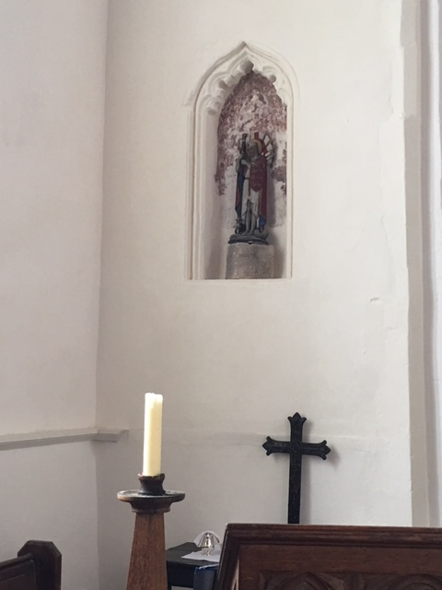

During the preparations for painting of the chancel Ashley Courtney our Architect suggested painting the chancel in a different colour, and after a number of samples it was agreed to limewash the chancel in a pale yellow colour called Bloomsbury Yellow supplied by Rose of Jericho. The classical architraves to the windows were painted white in distemper, together with the dado and other mouldings. Altogether it has made a great impression and has made the chancel much warmer and welcoming. Newmarket Painters where extremely accommodating and ensured we had an extremely professional finish to walls that were far from easy to paint- in many areas we had to apply up to 6 coats of limewash to ensure we overcame the lifting off of old paint. We thank them for their valued contribution to the overall finish achieved.

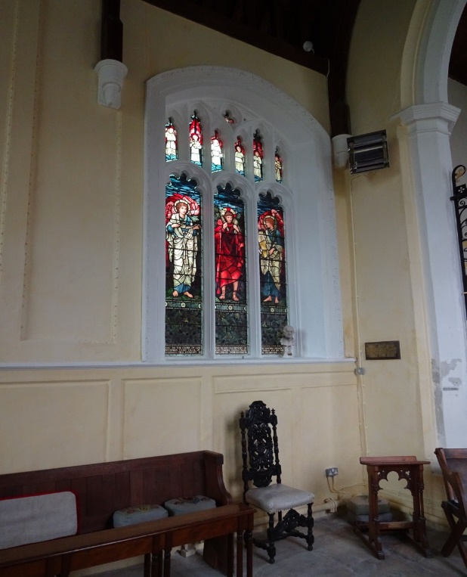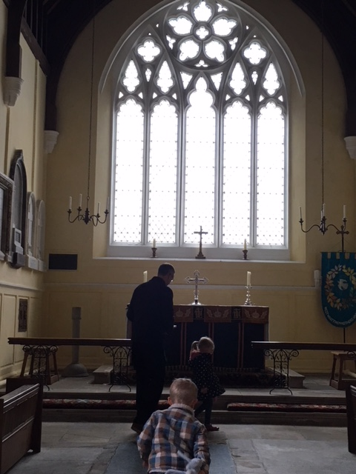

Also, whilst the scaffolding was up in the nave, we brought in a glazier, Terry Lankester, to refurbish the clerestory lights. Although we did not know it at the time – the windows were in a potentially dangerous condition and could have fallen into the Church. The refurbishment includes taking out the ventilating hoppers that had been inoperable. These were reglazed, and now work and we can adequately ventilate the church without leaving the doors open which runs to the risk of birds flying in and making a mess.

Not content with all that we undertook another project, once the scaffold was down, to carry out some re-ordering at the west end of the nave. Here, some C19 pews remained, and on the north side there was the last remaining raised pew platform. Following a successful faculty and tenders, George Collin and Sons Ltd undertook the works to lower the timber suspended floor flush with the nave floor. We altered the position of the radiators and relocated some of the pews around the edges. This has removeda significant trip hazard and allowed greater flexibility in that area of the Church.

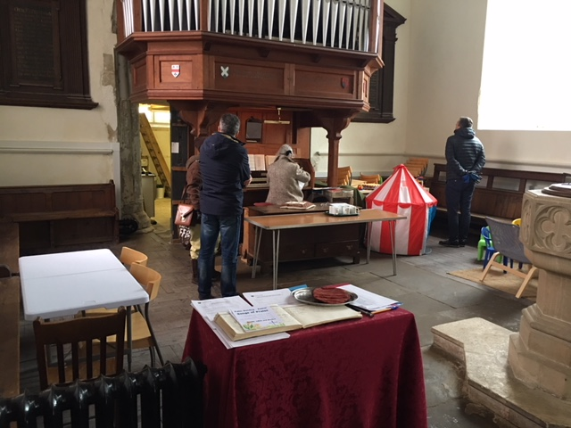

We look forward to 2018 with renewed energy to develop the Toilet and disabled access project. We will also obtain estimates for further works that may be needed in relation to damp and to ensure that rain water is allowed to flow away rather than sit in gulleys etc.

**Fund Raising Events**

The total funds raised during the year were £2,530 (£4,323) from the August Clay Shoot.

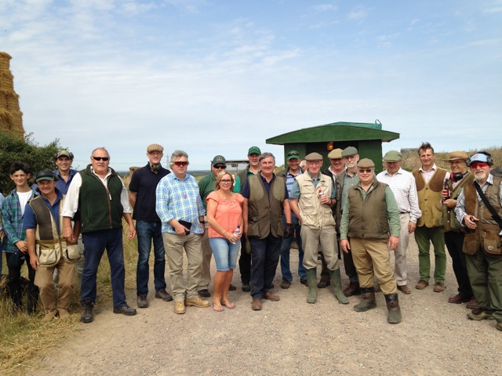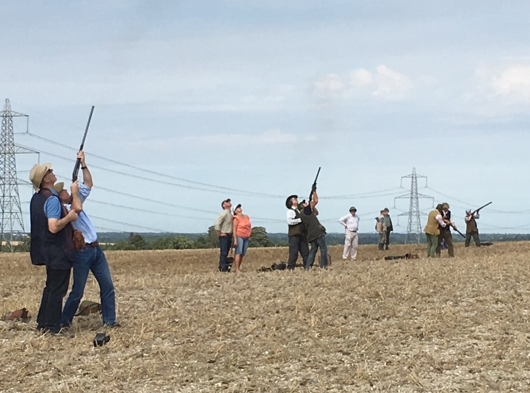

We thank Simon Sampson for organising the Shoot event and their teams of helpers who made them happen.

**Challenge**

In January 2000, Challenge ran to 8 pages and included 22 adverts. I took over as editor in 2008, and Challenge now averages 18 pages, with 42 adverts. It is still broadly recognisable as the same publication, with many of the same names and businesses, but now includes much more general news and items relating to the wider neighbourhood, rather than only concentrating on church news and the two villages. Of course, church events and local news still feature largely, but it is no longer simply ‘the church magazine’.

400 copies are printed monthly, delivered free of charge to all houses in both villages, and it is also sent by email to another 54 households and organisations.

Over the last few years the magazine has generally shown a small surplus of income over costs, and this profit has been shared between the two churches at the end of the year; equally, any shortfall would be met by the PCCs, as no balance was built up. Printing costs rose last year, and though we increased advertising charges slightly as well, Challenge is dependent on the willingness of local businesses to advertise, and on the generosity of local organisations such as the parish councils to subsidize this important community service. No one involved in the production of the magazine charges anything for their time and resources, so the only costs are printing and the licence for the email address.

Each page costs approximately £10 to print, so lengthy submissions do become expensive! I believe that Challenge is valuable to the villages, and would be missed if it could not be produced, so it is important that it is supported, both financially by way of grants where possible, and also by the continuation of all the voluntary input involved, including the distributors in both villages, and those who deliver it faithfully in all weathers.

We thank our stoical editor of Challenge, Anne Bragg, for all the hard work she puts into collating all the editorial, news and advertisements. This is no mean task and our villages are much indebted to her and to those who deliver the copies to over 450 households. I am sure everyone will agree that the monthly magazine is invaluable to all of us, and so is Anne!

**The 7 Parishes Choir**

**Report of the Music Minister**

It is my pleasure to present a brief report

1. **Seven Churches Choir**

The choir was formed in 2014 by the merger of the Abington and Hildersham Choir with the’ Four Churches Choir’ and continues to flourish. The choir is a prime example of what we can achieve to our mutual benefit across our parishes when we combine the considerable talent available to us.

The members of the choir are drawn from all the churches in the Grata Vale group, and all have shown considerable commitment by meeting regularly each week for practice. The aim of the choir is to enhance and lead worship by making a joyful song to God, to improve the standard of our singing and, very importantly to have fun in doing so which I think we do. I am proud of the achievements of our choir and most grateful to them for what they do.

The choir have sung at each of the United Services in the parishes as well as at a number of special services including the Stations of the Cross in Balsham, the Arts Festival in Hildersham, the Christmas Tree Festival in Balsham, the outstanding Nine Lessons and Carols Festival in Hildersham to name some but not all, they have also taken part in the RSCM Diocesan Choirs Festival in Ely Cathedral which I think we all found an inspiring event. Although there has not been a concert this year in aid of St Andrew’s, the choir are anxious to contribute when the occasion arises. I always appreciate suggestions as to services or occasions where the presence of the choir would be welcome.

The choir was delighted to form a relationship with the Sampfords Singers from North Essex and to join with them for Evensong in Radwinter and at our Arts Festival in Hildersham.

Anyone who enjoys singing in church and is willing to commit to practice is welcome in the choir -there are no auditions and no requirement to read music but you must be willing to have fun singing. Practice is held on Monday 19.15 – 20.30 in church – do please contact me or any choir member if you would like to know more.

1. **Organists and Musicians**

I am hugely grateful to all those, organists and other musicians, who regularly contribute to the provision of music in our churches and in that respect offer especial thanks to Jackie Romanis for her unfailing loyalty to music in West Wratting.

I look forward to the licencing of a new Priest in Charge of our Parishes and to working with that person to develop music here, doubtless we shall explore new forms of music and alternative means of accompaniment but I am sure there will remain a need for organists and in that respect, feel we must now take steps to ensure the sustainability of that role.

As I reminded the Joint PCCs recently, those of us who play the organs in our churches are growing no younger, for example I was in my 30’s when I took up the role of organist in the Abingtons and Hildersham and somehow, I now find myself in my 70’s, and it is essential that we take steps to increase the number of people willing to undertake this role on a regular basis. I will therefore be making a proposal to all the PCCs that we each contribute a modest sum in order to fund one or more organ scholarships to train competent keyboard players to become competent organists and to use those skills for the benefit of all our churches.

**Keith Day**

**01223 891527**

**keithdday@btinternet.com**

**The Parish Nurse**

**Report of the Chairman, Parish Nurse Management Committee**

1. **Progress to date**

It is hard to realise that we are now in the third year of the Parish Nurse Project and at the point where we need to take stock of what has been achieved thus far, before looking forward to the development of the service in the future.

As was predicted at the outcome, the project has uncovered a significant amount of need in our villages that was unmet and, in many cases also hidden. Since the inception of the project more than 100 individuals have been helped by the Parish Nurse of whom 75% have not been church attenders. On average Claire, our nurse, has 80 patient contacts per month and receives 4-5 new referrals each month – given that discharges are fewer than referrals her workload continues to rise. The project has been without question an outstanding success and is hugely appreciated by those who have used it.

The attached leaflet gives a summary of progress with the project thus far and outlines our plans for the future.

1. **The Future**

As well as the growing demand from the existing patient base we are conscious that there are a number of groups, young people, mothers and children for example who are only receiving limited benefit from the service and with whom we are not making contact.

Similarly, we are aware of the significant amount of voluntary help that is available across our communities but is not always coordinated and well publicised. There are in addition a number of individuals who would be willing to offer their time and talents to the project but Claire cannot be expected to organise them as well as treat her patients.

Accordingly, as described in the leaflet we have decided to seek the necessary funding both to continue the much-valued work of Claire as our nurse but also to expand what we can offer by the appointment of a part-time Community Worker to compliment and support Claire’s role.

The leaflet gives some information regarding the achievements of the PN project thus far and what we think are exciting plans for the future. The Management Committee firmly believe that the Parish Nurse Project is a shining example of what the Church is willing and able to offer all in our communities and I hope you will feel inspired to support it.

If there is any further information that you would like regarding the Parish Nurse Project do please contact me

**Keith Day**

**26th February 2017**

**Granta Deanery Synod Report for 2017 -**

Deanery Synod Representatives and Clergy met 3 times & there was a special Open Deanery Synod in September, all chaired by the Rural Dean, Revd. Simon Talbott. I was only able to attend the April meeting & am grateful to Derek for representing the Parish in July.

The April meeting took place in All Saints' Church, Castle Camps.

Treasurer Bob Doel thanked all 24 Parishes for paying their 2016 Share in full, thus triggering a rebate from Ely, & announced that the Spring Fair in March had raised £1376 towards Deanery development support for the coming year. The new funding formula (which was accepted by 23 out of 24 of our Parishes) means finding an increase of 3% for all Deaneries in the Diocese for 2017 and 2018. Concern was expressed at how this would be apportioned across the Deanery.

Simon Talbott announced that Revd Petra Shakeshaft would be inducted at Hinkledux in July & thanked Granta Vale parishes for their hard work during their continuing vacancies.

Jenny Duke asked for contact volunteers for the YOUTHINC PROJECT in each parish.

Sarah King, Diocesan Safeguarding Officer, outlined the foundations of the new Safeguarding Policy for the protection & nurture of vulnerable people - young & old. A huge training programme would be set up at different levels: CO (1 hour online Basic Awareness for anyone), C1 (Foundation) for PCCs; C2 (Leadership) for key roles with children & CWs; C3 for Clergy and Lay Ministers; C4 for senior staff; over 5000 DBS checks would also be required.

Nominations were requested for the Deanery Lay Chair and Treasurer at least 4 weeks before the July meeting.

Parish Treasurers were invited to the July Deanery Meeting at All Saints', Harston.

Andrew Gore was elected as new Lay Chair & Michael Younger was co-opted to Synod as Treasurer. Andrew Walker and Bob Doel were thanked for their 9 & 19 years’ service respectively.

Jenny Duke announced that a small grant from the Mission Fund had enabled a pilot project for children leaving Sunday School to be set up in Hinkledux & the employment of a youth worker for monthly sessions at Hinxton & Connect Services at Stapleford. To fund a Youth Worker 2 days p.w. , Deanery must raise £7,500 from funds & donations to get match funding from Diocese for 3 years. Parishes were asked to contribute £100-300 but Abington PCC declined for the time being as it is already supporting the development of Messy Church in the village.

Paul Evans, Diocesan Secretary gave a presentation on the Diocesan Programme & Budget 2018. What the C of E does for the next 5 years will set the pattern for the next 50. We need to hand things on in a better state than we received them. Diocese is in a fortunate position financially, but needs to raise Share by rate of inflation. Ely is a pilot Diocese for "setting God's people free" - encouraging the Laity into discipleship. Of £500,000 Growth Fund, only £14k has been spent so far. Several PCCs had tabled questions for Mr. Evans, mainly concerning finances. Few received satisfactory answers.

A Deanery Synod Open Meeting took place at St. Mary's, Sawston in September. There had been several incidents involving criminal damage & we were reminded once again to check insurance and security measures in our own parishes.

Francis Spufford, Granta Deanery Representative for General Synod, gave an introduction to the composition and role of the General Synod. It is a very complex organisation & enables a Christian voice to be heard on current issues, eg. inequality and how this can be reduced, welcoming transgender people, engagement with other faiths and with the public, especially through life events.

Treasurer, Michael Younger, reported a reserve of £68,000, the majority being £42,000 in the Parish Grant Fund which is used to support the Ministry Share.

At the November meeting at St. Peter's, Duxford, Treasurer Michael Younger advised the establishment of a Reserves Policy to ensure sufficient money to meet emergencies & mission & ministry initiatives. Almost all parishes (including W. Wratting and Hauxton) were on course to meet 100% of their Share for 2017, but he was concerned about a shortfall (£2,390) from Lt. Shelford, which would mean the Deanery would lose its rebate from Ely. It was hoped that the Archdeacon & Rural Dean would be still able to resolve the situation.

Jenny Duke reported a good response from parishes for YOUTHINC Project, also from 4 parishes in Shingay Deanery. The key challenges are: building relationships with Youth Worker, maintaining commitment, spreading the load among volunteers, transport in rural areas, valuing the small - Project worthwhile even for small no. of people. Proceeds from 2018 Deanery Fair will go to YOUTHINC.

Peter Wood, Diocesan Director of Mission, gave a presentation on Diocesan Strategy - to be fully alive. We need to invest in the future, but there is 2% decrease in church attendance p.a. Initiatives include Lent Course, Pioneer Partners, Building Audit, Generous Giving Scheme, Growth Fund, Market Town Adviser appointed, Secondary Schools Officer appointed in Huntingdon, Vocational Officer, 2year LLM training course at Ridley Hall.

Rev. Olivia Coles gave a brief talk about C of E research on Baptisms.Many thousands of people have contact with church through baptisms each year. Think about welcome and follow-up, Godparents' Sunday? MU making bags for baptised child. *www.churchofengland.org/life-events/christenings.*

Peter Wood's summary should encourage us: use the talents we have and share the burden; Mission and Ministry staff are willing to visit parishes, to support what we are doing and provide training. He stressed the importance of lay people to the Strategy.

**Marilyn Broadhurst**

**Deanery Representative for the Abington Parish, March 2018**

We are indebted to Marilyn for her excellent report – thank you

**Thank you**

The Very Revd Keith Johnson, on behalf of the Rural Dean, the Revd Simon Talbot and the members of the Ministry Team, thanks Alex Walsham and Sebastian Bain for their hard work as Churchwardens, and Catherine Willcocks and Jeanette Job for acting as assistant Church Wardens.

Thanks are due to Gary Birditt for his dedication and advice as Treasurer, Linda Gorman as Secretary, Ian Creek for acting as the independent auditor and the members of the PCC for their continual endeavours, as well as the many individuals that have ensured that we had flowers in church through the year and have cleaned and polished the church so beautifully. Thanks to Colin McCall for ensuring that everything is tidy in the Church and the graveyard, and Sisse McCall for ensuring the rota for opening and closing the church to ensure we keep our church open and also to everyone for their practical support in getting things done on so many levels. Thanks are also due to those who have set up for services and those who have provided the refreshments.

Ashley Courtney, our Architect. For his careful and time-consuming oversight of the repair work to the church during the past year, and his comprehensive set of alternative plans for the installation of a toilet for able and handicapped visitors to St. Andrew’s.

Many thanks to Jenny Knowelden for her role as sacristan.

A magnificent fund-raising effort has been managed by the PCC and individuals within the village. We are truly blessed, and the generosity of individuals within the village and even from far afield is truly appreciated. The support of The Wadlow Wind Farm, CHTC and Amey has ensured we have finally completed the repairs and that we have made St Andrew’s stronger for future generations. The re-ordering of the west end of St. Andrew’s to make it useable for children and for families so that we can serve all ages of our parishioner’s families has now been accomplished.

Finally, a word of thanks to our new Support Group and to all those in the village who have once again played their part in making last year such a full, satisfying and productive one for St Andrew’s.

**The Very Revd Keith Johnson**

**March 2018**

MINUTES OF THE ANNUAL PAROCHIAL CHURCH COUNCIL MEETING OF THE PARISH OF ST ANDREW’S, WEST WRATTING

**Held in St Andrew’s**

**On Sunday 12th March 2017 at 11.45 am**

**MEETING OF PARISHIONERS TO ELECT CHURCHWARDENS**

|  |  |  |  |  |
| --- | --- | --- | --- | --- |
|  | |  | | ACTION |
| **1.**  **2.**  **3.**  **4.**  **5.**  **6.**  **1.**  **2.** | | Rev Keith Johnson welcomed everyone to the meeting He then opened the meeting with a prayer apologies for Absence Apologies were received from Mr Gary Birditt (Treasurer), Mr Sebastian Bain, Mrs Catherine Willcocks, Mr Ben Willcocks, Mr James Morrow, Mrs Jeanette Job  **MINUTES OF THE LAST MEETING**  The minutes of the Meeting held on Monday 11th April 2016 and that of 22nd August 2016 to appoint Prof Alex Walsham as second Church Warden were approved and signed as a correct record of the proceedings. Matters arising There were no matters arising Election of Churchwardens There were two submissions for election of Churchwarden – John J S Bain and Alexandra Walsham, who had been proposed and seconded. It was formally put to the vote and unanimously supported that they should be re-elected for the coming year.  Keith thanked Sebastian for all his work and Alex for her support and strength. He was, as were we all, grateful to her for feeling able to take on the church warden’s duties.  The meeting was then closed.  **ANNUAL PAROCHIAL CHURCH MEETING**  The Very Revd Keith Johnson welcomed everyone. Keith felt that the discussions so far proposed developments and changes had been very successful and there was any difficulty over agreeing it can be held over until September when we will, hopefully, have a new Rector. Keith asked for apologies and handed over the meeting to Alex Walsham. Alex thanked Keith. apologies for Absence Apologies were received from Mr Gary Birditt, Mr Sebastian Bain, Mrs Catherine Willcocks, Mr Ben Willcocks, Mr James Morrow, Mrs Jeanette Job | |  |
| **3.** | | **MINUTES OF THE LAST MEETING**  The minutes of the Annual Meeting held on Monday 11th April 2016, having been made available, were approved and signed as a correct record of the proceedings. | |  |
| **4.** | | MATTERS ARISINGThere were no matters arising not covered elsewhere on the agenda. | |  |
| **5.** | | THE REPORTS **Church Warden’s Report**  Alex confirmed that she had received the reports which had been circulated as well as being in the booklets.  It had been a very eventful year with the loss of the roof lead but tremendous progress had been made and she was grateful to all those who responded and helped. Thanks to all from herself, Sebastian and all the PCC.  **Electoral Roll**  Simon Sampson confirmed that the numbers on the Electoral Roll now stood at 31.  **Report of the Financial Statement of the PCC for the year ended 31st December 2016**  Alex directed people to the Financial Report in the booklet. Simon Sampson proposed that it be accepted and this was seconded. The accounts were then formally adopted.  Thanks were due to Gary Birditt for his work on the accounts for which we were very grateful and to Ian Creek for auditing the accounts. Thanks, were also due to Catherine for all her work.  **Report on the Goods, Fabric and Ornaments of the Church**  Alex thanked all those who helped with looking after the church, in particular, the churchyard cleanups, especially Colin McCall for organising these. Also, Mark Addley and Phil O’Donovan for co-ordinating all the work on the church roof. This process is on schedule to be completed in April and then the redecorating will begin. Alex asked if there were any further comments but there were none.  **Report of the Bell Ringers**  The report of the Bell Ringers was in the booklet. Alex thanked Mike Rowland for his services and support as Tower Captain and the other bell ringers.  **Report from the Deanery Synod**  Alex referred those present to the report and asked if there were any comments. There were none. | |  |
| **6.** | | | ELECTIONS AND APPOINTMENTS The current Lay Parochial Church Members were Linda Gorman, Jeanette Job, Simon Sampson, Catherine Willcocks and Keith Johnson, ex-officio, with Alex Walsham and Sebastian Bain as church wardens. They were all willing to continue. It was proposed by Colin McCall that they be accepted, seconded by Sisse McCall and accepted.  All our current the sidesmen. Mrs Jenny Knowelden, Mr Colin McCall and Mrs Sisse McCall, Mr Ben Willcocks, Prof Alex Walsham and Mrs Frances Peers were re-appointed. Alex said that we would welcome anyone else who would be willing to do this and they should contact her about this.  Jeanette had agreed to continue as our Deanery Synod representative. 7. APPOINTMENT OF INDEPENDENT EXAMINER OF ACCOUNTS Ian Creek was prepared to stand again in this position. Thanks, were given to him for reviewing the accounts and his excellent report. His re-appointed for the next year was agreed. |  |
|  | | |  |  |
|  |  | | |  |
| **8.** | **INTERREGNUM – WHERE WE ARE NOW**  The six parishes have met on several occasions over a number of months. They had prepared a profile which had been approved by the Archdeacon. The position is now being advertised on the website and will in due course appear in the *Church Times*. The timetable is as follows – closing date for applications 19th May, short list will be drawn up the following week, with the date for interviews being 19th June. The community will also have an opportunity to meet the candidates at a social event and for them to visit the churches. Two representatives from West Wratting will be involved in this process. Alex would be one and it was proposed that Catherine be the other.  Alex asked if there were any questions. She said that thanks were due to the Standing Committee of the six parishes, in particular, Andrew Westwood-Bate for the beautiful profile document. It was hoped that the new Priest in Charge would take up the post in the Autumn.  Jenny Knowleden asked where they would reside. Alex explained that the Priest in Charge would be in Balsham and then there would be a further process to appoint a House for Duty Priest who would be in Great Abington.  Sisse asked if there was any likelihood of revisiting this decision. Alex said that the new priest in charge would play a key role in this appointment, but that it was expected that the House for Duty priest would indeed reside in Great Abington. | | |  |
| **9.** | **Toilets, disabled access, and possible reorganisation of Church Layout** | | |  |
|  | Alex initiated discussion on this matter, saying that there had been considerable and a pleasing number of responses to the proposal circulated by e-mail.  The Proposal follows the informal meeting where many ideas were put forward and discussed about keeping the church as the heart of the community and different kinds of worship. She stressed the need to remember that churches are communities of people which change over time.  The intention is to improve disabled access and consider installing toilets. Concerning the latter, what has happened at Hildersham is a very sympathetic conversion. Many people are unable to come in to St Andrew’s at present and this is necessary if the building is to be used for a variety of purposes.  The second question is the possibility of reconfiguring the space at the back of the church. There proposals were for discussion and consideration and there would be no formal decision at this meeting, after which there would be time to reflect upon and explore the ideas.  We are considering moving the pews at the back of the church into storage, opening up the back for more informal worship. This would enable tables and chairs around for different kinds of service e.g. café church.  The overwhelming responses were positive although some people had concerns. In particular, what provision would be made for the Seven Churches Choir and the location of the toilets at the North Door.  She then opened the meeting for comments.  Sisse McCall suggested that if the pews were moved one should be kept on either side to keep the cross-shape of the church. Alex said that the current radiator s would be (re)moved and smaller ones installed. Jenny Knowleden was in favour of moving the choir stalls to the Chancel.  Diana Edwards said that Sebastian had pointed out that a faculty would be needed to do this.  Linda Gorman raised a concern about the distance that they would be from the organ. Simon Sampson was in favour of preserving the choir stalls and agreed that they could be kept in the Chancel as, if they were put into storage, they would probably never be seen again. This was the normal position for them.  Alex explained that the proposal had been seen by Keith Day, our choirmaster, and he thinks it would not cause problems and would like to use chairs. Raymond Maskell commented that when he was a member of the choir, he had felt the organ was too close.  Carrie Pemberton-Ford that we need to keep in mind what we are trying to do, giving a better welcome, with space for children, not only a place outside. Smaller Eucharist services could be in the Chancel as in Weston Colville. Alex said that this had been raised at the meeting in November. If this was pursued, there would need to be better heating in the Chancel.  There was a sense at the last meeting that some people found it intimidating. Cobby commented that when he is working in the churchyard people have asked if it was permitted to go into the church. It is important to have a friendly ambience while maintaining the integrity of the church. It is highly desirable to have a welcoming area for youngsters who wish to come in and sit and talk.  John Harvey said that he and Scilla said that they fully endorsed clearing out the pews which would make a much better area. John said that at a previous church he had attended they had cleared out all the pews.  Alex stressed that it was important to embrace change to ensure that we have a congregation in the future. As an ecclesiastical historian she pointed out that changes in church furniture had happened regularly. The pews had not been here for much of the previous 700 years. Carrie Pemberton Ford pointed out that it had been Jesus who through the tables out of the Temple.  Linda said that, in relation to the proposed work outside the North Door, we should keep in mind the possibility of burials as it had been the tradition to bury un-christened babies by the North Wall of churches.  Clive Parry asked what the timetable for this work on the space at the back of the church and the disabled access would be. Alex explained that these would be dealt with separately. Nothing could happen until a faculty had been applied for but possibly 6 – 9 months. Simon Thorley, who admitted to having been a church warden at his previous church, said he had found that one needed to be extraordinarily patient and that 6 – 9 months might be rather a short time-line. The new rector would want some input into this but this would be our appointment aligned with our vision.  Phil O’Donovan asked if the PCC raises the request. Alex confirmed that this was the case and we would prepare the application.  Sisse said that she was pleased to hear that the sort of events proposed were mainly church ones and not events that could be held in the Village Hall. Alex said that this point had also been raised at the previous meeting.  **10. Any Other Business**  Cobby thanked the PCC for all their work. It had been a turbulent year but we had managed to turn things around. Thanks, were also due to Sebastian.  **11.** At Alex’s request, Carrie Pemberton-Ford closed the meeting with a prayer. | | |  |

|  |  |  |  |  |
| --- | --- | --- | --- | --- |
|  | |  | |  |
|  | | |  |  |
|  | | |  |  |
|  |  | | |  |

**St Andrew’s, West Wratting**

**Annual Church Meeting**

**Tuesday, 27 March 2018 at 7.00 pm in St Andrew’s Church**

**AGENDAS**

**MEETING OF PARISIONERS TO ELECT CHURCHWARDENS**

1. Welcome The Revd *Simon Talbot*
2. Opening prayers The Ver *Revd Keith Johnson*
3. Apologies for absence  *The Ver Revd Keith Jonson*
4. Minutes of the meeting of 12th March 2017
5. Matters Arising
6. Election of Churchwardens

**ANNUAL PAROCHIAL CHURCH MEETING**

1. Welcome *The Revd Simon Talbot*
2. Apologies for absence
3. Minutes of the meeting of 12th March 2017
4. Matters Arising
5. The Reports

* Church Wardens report
* Electoral Roll –
* Annual Report of the PCC -
* Report of the Financial statement of the PCC for the year ended 31st December 2017
* Report on the Goods, Fabric and Ornaments of the Church
* Bell Ringer’s Report
* Report from the Deanery Synod

1. Elections and Appointments

* Election of Lay Parochial Church Council Members -
* Appointment of Sidesmen –
* Deanery Synod Representative -

1. Appointment of Independent Examiner of Accounts -
2. Interregnum – statement about where we are now.
3. Toilets and Disabled Access
4. Closing Prayers.

**PCC MEETING**

1. Election of Treasurer and Secretary

2. Standing Committee

3. Date of Meetings:

18th May at 7.30 pm Joint PCC at Great Abington

(Date to be confirmed) July St Andrew’s Church 8pm

(Date to be confirmed) September St Andrew’s Church 8pm

*Apologies to Linda Gorman Tel:* 01223 290653 email: lcg3@btinternet.com

|  |  |  |  |  |  |  |  |  |  |  |  |
| --- | --- | --- | --- | --- | --- | --- | --- | --- | --- | --- | --- |
|  |  |  |  |  |  |  |  |  |  |  |  |
|  |  |  | West Wratting Parochial Church Council | | | | |  |  |  |  |
|  |  |  |  |  |  |  |  |  |  |  |  |
|  |  |  |  |  |  |  |  |  |  |  |  |
|  |  |  | Receipts & Payments Accounts | | | |  |  |  |  |  |
|  |  |  |  |  |  |  |  |  |  |  |  |
|  |  |  |  |  |  |  |  |  |  |  |  |
|  |  |  | For the Year ended 31st December 2017 | | | | |  |  |  |  |
|  |  |  |  |  |  |  |  |  |  |  |  |
|  |  |  |  |  |  |  |  |  |  |  |  |
|  |  |  |  |  |  |  |  |  |  |  |  |
|  |  |  |  |  |  |  |  |  |  |  |  |
|  |  |  |  |  |  |  |  |  |  |  |  |
|  |  |  |  |  |  |  |  |  |  |  |  |
|  |  |  |  |  |  |  |  |  |  |  |  |
|  |  |  |  |  |  |  |  |  |  |  |  |
|  |  |  | Contents |  |  |  |  |  |  |  |  |
|  |  |  | Page |  |  |  |  |  |  |  |  |
|  |  |  |  |  |  |  |  |  |  |  |  |
|  |  |  | 1 General Fund Account | |  |  |  |  |  |  |  |
|  |  |  |  |  |  |  |  |  |  |  |  |
|  |  |  | 2 Challenge Magazine Account | | | |  |  |  |  |  |
|  |  |  | Roof Account |  |  |  |  |  |  |  |  |
|  |  |  | Church Central Board of Finance Interest | | | | | |  |  |  |
|  |  |  |  |  |  |  |  |  |  |  |  |
|  |  |  | 3 Restoration Fund Account | | | |  |  |  |  |  |
|  |  |  |  |  |  |  |  |  |  |  |  |
|  |  |  | 4 Assets & Liabilities | |  |  |  |  |  |  |  |
|  |  |  | Bank Balances | |  |  |  |  |  |  |  |
|  |  |  | Summary of Receipts over Expenditure | | | | | |  |  |  |
|  |  |  | Debtors |  |  |  |  |  |  |  |  |
|  |  |  | Sundry Assets | |  |  |  |  |  |  |  |
|  |  |  | Sunday School Funds | | | |  |  |  |  |  |
|  |  |  |  |  |  |  |  |  |  |  |  |
|  |  |  |  |  |  |  |  |  |  |  |  |
|  |  |  |  |  |  |  |  |  |  |  |  |
|  |  |  |  |  |  |  |  |  |  |  |  |
|  |  |  |  |  |  |  |  |  |  |  |  |
|  |  |  |  |  |  |  |  |  |  |  |  |
|  |  |  |  |  |  |  |  |  |  |  |  |
|  |  |  |  |  |  |  |  |  |  |  |  |
|  |  |  |  |  |  |  |  |  |  |  |  |
|  |  |  |  |  |  |  |  |  |  |  |  |
|  |  |  |  |  |  |  |  |  |  |  |  |
|  |  |  |  |  |  |  |  |  |  |  |  |
|  |  |  |  |  |  |  |  |  |  |  |  |
|  |  |  |  |  |  |  |  |  |  |  |  |
|  |  |  |  |  |  |  |  |  |  |  |  |
|  |  |  |  |  |  |  |  |  |  |  |  |
|  |  |  |  |  |  |  |  |  |  |  |  |
|  |  |  |  |  |  |  |  |  |  |  | Page 1 |
|  |  |  |  |  |  |  |  |  |  |  |  |
|  |  |  |  |  |  |  |  |  |  |  |  |
|  |  |  |  |  |  |  |  |  |  |  |  |
|  |  |  |  |  |  |  |  |  |  |  |  |
|  |  |  |  |  |  |  |  |  |  |  |  |
|  |  |  |  |  |  | 2017 |  |  |  | 2016 |  |
| **General Fund** | | | |  |  |  |  |  |  |  |  |
|  | Receipts | | |  |  |  |  |  |  |  |  |
|  |  |  |  |  |  |  |  |  |  |  |  |
|  |  | Voluntary Income | |  |  |  |  |  |  |  |  |
|  |  |  | Gift Aid donations | 11,635 |  |  |  | 10,742 |  |  |  |
|  |  |  | Gift Aid tax rebate (previous year's) | 3,388 |  |  |  | 3,007 |  |  |  |
|  |  |  |  |  |  | 15,023 |  |  |  | 13,749 |  |
|  |  |  |  |  |  |  |  |  |  |  |  |
|  |  | Other Income | |  |  |  |  |  |  |  |  |
|  |  |  | Dividends & bank interest | 64 |  |  |  | 88 |  |  |  |
|  |  |  | War Stock redemption | 0 |  |  |  | 0 |  |  |  |
|  |  |  | Funerals, weddings & baptisms | 2,450 |  |  |  | 2,909 |  |  |  |
|  |  |  |  |  |  | 2,514 |  |  |  | 2,997 |  |
|  | Total Receipts | | |  | £ | 17,537 |  |  | £ | 16,746 |  |
|  |  |  |  |  |  |  |  |  |  |  |  |
|  | Payments | | |  |  |  |  |  |  |  |  |
|  |  |  |  |  |  |  |  |  |  |  |  |
|  |  | Payments to Charities | |  |  |  |  |  |  |  |  |
|  |  |  | Children in Need | 150 |  |  |  | 150 |  |  |  |
|  |  |  | British Legion | 25 |  |  |  | 25 |  |  |  |
|  |  |  | Leprosy Mission | 0 |  |  |  | 25 |  |  |  |
|  |  |  | Tearfund | 330 |  |  |  | 0 |  |  |  |
|  |  |  |  |  |  | 505 |  |  |  | 200 |  |
|  |  | Other payments | |  |  |  |  |  |  |  |  |
|  |  |  | Parish share | 8,828 |  |  |  | 8,422 |  |  |  |
|  |  |  | Church : light, heat & water | 643 |  |  |  | 731 |  |  |  |
|  |  |  | Cost of services & vicar's expenses | 1,621 |  |  |  | 1,700 |  |  |  |
|  |  |  | Candles, wine & wafers | 115 |  |  |  | 255 |  |  |  |
|  |  |  | Organists honorarium | 500 |  |  |  | 525 |  |  |  |
|  |  |  |  |  |  | 11,707 |  |  |  | 11,633 |  |
|  | Total Payments | | |  | £ | 12,212 |  |  | £ | 11,833 |  |
|  |  |  |  |  |  |  |  |  |  |  |  |
|  | Excess of Receipts over Payments | | |  | £ | 5,325 |  |  | £ | 4,913 |  |
|  |  |  |  |  |  |  |  |  |  |  |  |
|  |  |  |  |  |  |  |  |  |  |  |  |
|  |  |  |  |  |  |  |  |  |  |  |  |
|  |  |  |  |  |  |  |  |  |  |  |  |
|  |  |  |  |  |  |  |  |  |  |  |  |
|  |  |  |  |  |  |  |  |  |  |  |  |
|  |  |  |  |  |  |  |  |  |  |  |  |
|  |  |  |  |  |  |  |  |  |  |  |  |
|  |  |  |  |  |  |  |  |  |  |  |  |
|  |  |  |  |  |  |  |  |  |  |  |  |
|  |  |  |  |  |  |  |  |  |  |  | Page 2 |
|  |  |  |  |  |  |  |  |  |  |  |  |
|  |  |  |  |  |  |  |  |  |  |  |  |
|  |  |  |  |  |  |  |  |  |  |  |  |
|  |  |  |  |  |  |  |  |  |  |  |  |
|  |  |  |  |  |  |  |  |  |  |  |  |
|  |  |  |  |  |  | 2017 |  |  |  | 2016 |  |
|  |  |  |  |  |  |  |  |  |  |  |  |
| **Challenge Magazine** | | | |  |  |  |  |  |  |  |  |
|  | Receipts | | |  |  |  |  |  |  |  |  |
|  |  | Advertisements | |  |  | 1,636 |  |  |  | 1,993 |  |
|  |  | Donations | |  |  | 75 |  |  |  | 75 |  |
|  |  |  |  |  |  | 1,711 |  |  |  | 2,068 |  |
|  |  |  |  |  |  |  |  |  |  |  |  |
|  | Payments | | |  |  |  |  |  |  |  |  |
|  |  | Printing costs | | 2,106 |  |  |  | 2,066 |  |  |  |
|  |  | From Weston Colville re share of deficit | | -197 |  |  |  | 0 |  |  |  |
|  |  |  |  |  |  | 1,909 |  |  |  | 2,066 |  |
|  |  |  |  |  |  |  |  |  |  |  |  |
|  | Excess of Payments over Receipts | | |  | £ | -198 |  |  | £ | 2 |  |
|  |  |  |  |  |  |  |  |  |  |  |  |
|  |  |  |  |  |  |  |  |  |  |  |  |
|  |  |  |  |  |  |  |  |  |  |  |  |
|  |  |  |  |  |  |  |  |  |  |  |  |
|  |  |  |  |  |  |  |  |  |  |  |  |
| **Roof & Associated Costs** | | | |  |  |  |  |  |  |  |  |
|  | Receipts | | |  |  |  |  |  |  |  |  |
|  |  | Trusts and Charity Donations | |  |  | 40,000 |  |  |  | 18,000 |  |
|  |  | Cambs Historic Church Trust Loan | |  |  | 20,000 | *** |  |  | 0 |  |
|  |  | Insurance Claim | |  |  | 0 |  |  |  | 15,000 |  |
|  |  | Personal Donations | |  |  | 17,997 |  |  |  | 18,126 |  |
|  |  |  |  |  |  | 77,997 |  |  |  | 51,126 |  |
|  | Payments | | |  |  |  |  |  |  |  |  |
|  |  |  | Roof Cost | 81,218 | **\*** |  |  | 8,725 |  |  |  |
|  |  |  | Decorating | 17,289 | **\*** |  |  | 0 |  |  |  |
|  |  |  | Lowering of Floor | 12,185 | ** |  |  | 0 |  |  |  |
|  |  |  | Plastering | 7,214 | **\*** |  |  | 0 |  |  |  |
|  |  |  | Windows | 3,942 | **\*** |  |  | 0 |  |  |  |
|  |  |  | Electrical work | 7,046 | **\*** |  |  | 0 |  |  |  |
|  |  |  | Pew Removal | 630 |  |  |  | 0 |  |  |  |
|  |  |  |  |  |  | 129,524 |  |  |  | 8,725 |  |
|  |  |  |  |  |  |  |  |  |  |  |  |
|  | Excess of Payments over Receipts | | |  | £ | -51,527 |  |  | £ | 42,401 |  |
|  |  |  |  |  |  |  |  |  |  |  |  |
|  |  | Notes : - | |  |  |  |  |  |  |  |  |
|  |  |  | * Denotes that VAT was recovered on these repair costs | | | |  |  |  |  |  |
|  |  |  | The amounts are net of VAT |  |  |  |  |  |  |  |  |
|  |  |  | ** Denotes that VAT content will be claimed in 2018 as repairs now complete | | | | | | |  |  |
|  |  |  | *** The CHCT loan is repayable over 4 years. £5,000 was repaid in February 2018 | | | | | | | |  |
|  |  |  |  |  |  |  |  |  |  |  |  |
|  |  |  |  |  |  |  |  |  |  |  | Page 3 |
|  |  |  |  |  |  |  |  |  |  |  |  |
|  |  |  |  |  |  |  |  |  |  |  |  |
|  |  |  |  |  |  |  |  |  |  |  |  |
|  |  |  |  |  |  |  |  |  |  |  |  |
|  |  |  |  |  |  |  |  |  |  |  |  |
|  |  |  |  |  |  |  |  |  |  |  |  |
|  |  |  |  |  |  | 2017 |  |  |  | 2016 |  |
| **St Andrew's Restoration Fund** | | | |  |  |  |  |  |  |  |  |
|  | Receipts | | |  |  |  |  |  |  |  |  |
|  |  | Clay Pigeon Shoot | |  |  | 2,530 |  |  |  | 2,770 |  |
|  |  | Summer Fete | |  |  | 0 |  |  |  | 0 |  |
|  |  | St Andrew's Fair | |  |  | 0 |  |  |  | 0 |  |
|  |  | Harvest Supper- net | |  |  | 0 |  |  |  | 687 |  |
|  |  | Firework collection | |  |  | 0 |  |  |  | 260 |  |
|  |  | Lent Lunch | |  |  | 0 |  |  |  | 0 |  |
|  |  | Concerts | |  |  | 0 |  |  |  | 605 |  |
|  |  | Bell ringers donation | |  |  | 0 |  |  |  | 0 |  |
|  |  | Interest | |  |  | 0 |  |  |  | 1 |  |
|  |  |  |  |  |  | 2,530 |  |  |  | 4,323 |  |
|  | Payments | | |  |  |  |  |  |  |  |  |
|  |  | Repairs & maintenance : - | |  |  |  |  |  |  |  |  |
|  |  |  | General repairs - roof, pipes etc | 1,861 |  |  |  | 989 |  |  |  |
|  |  |  | Insurance | 1,629 |  |  |  | 1,629 |  |  |  |
|  |  |  | Organ service | 0 |  |  |  | 225 |  |  |  |
|  |  |  | Electric Piano | 939 |  |  |  | 0 |  |  |  |
|  |  |  | Fire precautions | 24 |  |  |  | 24 |  |  |  |
|  |  |  | Mower | 0 |  |  |  | 278 |  |  |  |
|  |  |  | Clock service | 0 |  |  |  | 1,072 |  |  |  |
|  |  |  | Boiler Service | 174 |  |  |  | 0 |  |  |  |
|  |  |  | Historic Church subscription | 50 |  |  |  | 0 |  |  |  |
|  |  |  |  |  |  | 4,677 |  |  |  | 4,217 |  |
|  |  |  |  |  |  |  |  |  |  |  |  |
|  | Excess of Payments over Receipts | | |  | £ | -2,147 |  |  | £ | 106 |  |
|  |  |  |  |  |  |  |  |  |  |  |  |
|  |  |  |  |  |  |  |  |  |  |  |  |
|  |  |  |  |  |  |  |  |  |  |  |  |
|  |  |  |  |  |  |  |  |  |  |  |  |
|  |  |  |  |  |  |  |  |  |  |  |  |
| **Church Central Board of Finance** | | | |  |  |  |  |  |  |  |  |
|  |  |  |  |  |  |  |  |  |  |  |  |
|  | Interest | | |  |  |  |  |  |  |  |  |
|  |  | General Deposit a/c | |  |  | 22 |  |  |  | 50 |  |
|  |  | Church Repairs Deposit a/c | |  |  | 0 |  |  |  | 55 |  |
|  |  |  |  |  | £ | 22 |  |  | £ | 105 |  |
|  |  |  |  |  |  |  |  |  |  |  |  |
|  |  |  |  |  |  |  |  |  |  |  |  |
|  |  |  |  |  |  |  |  |  |  |  |  |
|  |  |  |  |  |  |  |  |  |  |  |  |
|  |  |  |  |  |  |  |  |  |  |  |  |
|  |  |  |  |  |  |  |  |  |  |  | Page 4 |
|  |  |  |  |  |  |  |  |  |  |  |  |
|  |  |  |  |  |  |  |  |  |  |  |  |
|  |  |  |  |  |  |  |  |  |  |  |  |
|  |  |  |  |  |  |  |  |  |  |  |  |
| **Assets** | | | |  |  |  |  |  |  |  |  |
|  |  |  |  |  |  |  |  |  |  |  |  |
| **Bank Accounts** | | | |  |  | 31.12.17 |  | Year's |  | 31.12.16 |  |
|  |  |  |  |  |  | Balance |  | Movement |  | Balance |  |
|  |  | Lloyds | |  |  |  |  |  |  |  |  |
|  |  |  | General Fund |  |  | 15,228 |  | 12,816 |  | 2,412 |  |
|  |  |  | Restoration Fund |  |  | 18 |  | -5,089 |  | 5,107 |  |
|  |  |  | Challenge Fund |  |  | 214 |  | 208 |  | 6 |  |
|  |  |  | Organ & Clock Fund |  |  | 0 |  | -562 |  | 562 |  |
|  |  |  | Roof a/c |  |  | 5,001 |  | -37,400 |  | 42,401 |  |
|  |  |  |  |  |  | 20,461 |  | -30,027 |  | 50,488 |  |
|  |  | Church Central Board of Finance | |  |  |  |  |  |  |  |  |
|  |  |  | Church Repairs Deposit a/c |  |  | 0 |  | -8,185 |  | 8,185 |  |
|  |  |  | General Deposit a/c |  |  | 2,953 |  | -10,313 |  | 13,266 |  |
|  |  |  |  |  | £ | 23,414 | £ | -48,525 | £ | 71,939 |  |
|  |  |  |  |  |  |  |  |  |  |  |  |
|  |  |  |  |  |  |  |  |  |  |  |  |
| **Movement represented by results: Excess of Receipts over Payments : -** | | | | | | | | | | |  |
|  |  |  |  |  |  |  |  |  |  |  | Page |
|  |  |  | General Fund |  |  |  |  | 5,325 |  |  | 1 |
|  |  |  | Challenge |  |  |  |  | -198 |  |  | 2 |
|  |  |  | Roof & other Restoration Costs |  |  |  |  | -51,527 |  |  | 2 |
|  |  |  | St Andrew's Restoration Fund |  |  |  |  | -2,147 |  |  | 3 |
|  |  |  | Church Central Board of Finance |  |  |  |  | 22 |  |  | 2 |
|  |  |  |  |  |  |  | £ | -48,525 |  |  |  |
|  |  |  |  |  |  |  |  |  |  |  |  |
|  |  |  |  |  |  |  |  |  |  |  |  |
|  | **Notes** | | |  |  |  |  |  |  |  |  |
|  |  |  | **Amount Receivable** |  |  |  |  |  |  |  |  |
|  |  |  | Gift Aid tax refund due |  |  | £6,499 |  |  |  |  |  |
|  |  |  |  |  |  |  |  |  |  |  |  |
|  |  |  | **Amount Payable** |  |  |  |  |  |  |  |  |
|  |  |  | Cambs Historic Church Trust Loan |  |  | £20,000 |  |  |  |  |  |
|  |  |  | (Repayable in equal instalments over four years from 2018) | | | |  |  |  |  |  |
|  |  |  |  |  |  |  |  |  |  |  |  |
|  |  |  |  |  |  |  |  |  |  |  |  |
|  |  |  | Sundry Assets | 31.12.17 |  | 31.12.16 |  |  |  |  |  |
|  |  |  | CBF Investment 121 Income Shares | £1,639 |  | £1,819 |  |  |  |  |  |
|  |  |  |  |  |  |  |  |  |  |  |  |
|  |  |  |  |  |  |  |  |  |  |  |  |
|  |  |  | Sunday School Funds | 31.12.17 |  | 31.12.16 |  |  |  |  |  |
|  |  |  | CBF Sunday School Fund | £2,219 |  | £2,219 |  |  |  |  |  |
|  |  |  | Sunday School Lloyds Bank a/c | £7 |  | £200 |  |  |  |  |  |
|  |  |  |  | £2,226 |  | £2,419 |  |  |  |  |  |
|  |  |  |  |  |  |  |  |  |  |  |  |

To be updated

**Proposal to:**

**(1) Add disabled access and toilet facilities**

**Background**

The recent retirement of the local non-stipendiary vicar and the resignation of the priest-in-charge of the benefice has prompted the church wardens to canvass the whole village, including but not limited to the church goers, for their opinions on how St Andrew’s can serve the spiritual needs of a broader section of the community. There is a clear demonstration of a desire to widening the appeal of the church to all residents of West Wratting.

In addition, as part of the Ely 2025 Growth Strategy, we are in the process of developing action plans to address the key "levers of change", which include serving our communities and re-imagining our church buildings. Our growth strategy (Ely 2025) recognises that church buildings continue to draw and inspire people, even those of little or no explicit religious faith.

We recognise that the church plays a vital role in fostering inclusive communities regardless of faith and we’d like to see it as a hub of village life. As well as continuing the existing uses of our church building and grounds (including for bell ringing, annual fetes and Queen’s Birthday celebrations), we are now investigating ways of making the church a more welcoming and versatile space.

We are looking to enhance our visitor experience by adding disability access and a toilet facility. Having both disabled access and a toilet in the church increases the potential for welcoming visitors and the wider community into the building. It is also a useful facility for worshippers! We would like to discuss this possibility at the APCM.

The church building is open to all and is not simply a religious building; it is there for anyone who needs time for peace and time for contemplation to sit in, or just to drop in to meet others. The kitchen is used to make tea and coffee or a drink of squash by anyone visiting the church.

**Proposal**

We have been exploring options for disabled access and a wheelchair-friendly toilet facility with baby-changing facilities. Currently we are of the view that we should put the toilet in the tower and look to having a path around the church to the North Door where we believe we can, with adjustments to the steps and heating pipes, gain level access – the DAC has given their blessing to such a proposal should we agree to move forward on that basis.

**THE ECCLESIASTICAL PARISH OF**

**ST ANDREW’S CHURCH, WEST WRATTING**

**Our community**

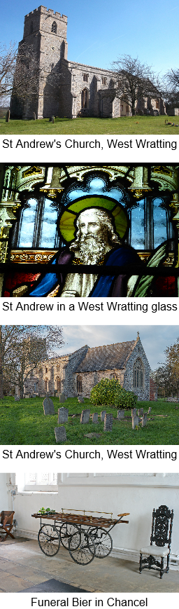West Wratting is a small village of approximately 450 people. The parish is a friendly place, has a strong sense of community, and is welcoming to newcomers. The housing is mainly concentrated along the High Street and Mill Road, but a number of households live on The Common, the road between Withersfield and West Wratting. The village is surrounded by agricultural land and farm estates and there are many attractive walks in the area. Residents commute to Cambridge (and its university, hospitals and science parks), Newmarket, Saffron Walden, and London to work.

The village has a pub, The Chestnut Tree, which is a focus for much regular social activity including a book group, over sixties meetings, and a third Thursday lunch. The landlords are very supportive of village events. There is a Village Hall, which was extensively refurbished to mark the Millennium and is well equipped with a kitchen, bar, stage and other facilities. It is overseen and managed by a committee and hosts a range of activities, including exercise and dance classes. It is also the venue for a Café which is held on the first Saturday of each month and run by a group of volunteers. This serves coffee and cake and provides a popular forum for conversation and social exchange. There is also a recreation ground, which is the base for a youth football club and the D’Abo tennis club. West Wratting has an annual Progressive Supper, which is an enjoyable opportunity to meet new people and share a meal together. The village is also in the vicinity of a former World War II RAF Bomber Command site (Wratting Common) and there is a yearly service on Remembrance Day there.

Regular fund-raising events for the church include a Pet and Produce Show (including a dog show and a teddy bear parachute drop from the tower) in early August; a clay-shooting day in late August; a Harvest Supper in September; and an annual Autumn Concert in October (normally held in Balsham church). The church and churchyard have also been at the centre of village celebrations, including parties to mark the recent Queen’s 90th Birthday and Jubilee anniversaries.

The parishes of West Wratting and Weston Colville Fund have a magazine, the *Challenge*, which is published monthly. The village also has its own website.

**Our worship**

The morning service (normally said Eucharist) is currently held at 10.45. We use a red service book based on Common Worship and using contemporary language. Hymns are sung with organ accompaniment. There are four well attended family-friendly Songs of Praise services per year at 4pm on Sunday. These are organised by John and Scilla Harvey, who bring musicians and singers from outside the village to enliven the service. Drinks and refreshments follow. There is a carol service and Christingle service for children. West Wratting and Weston 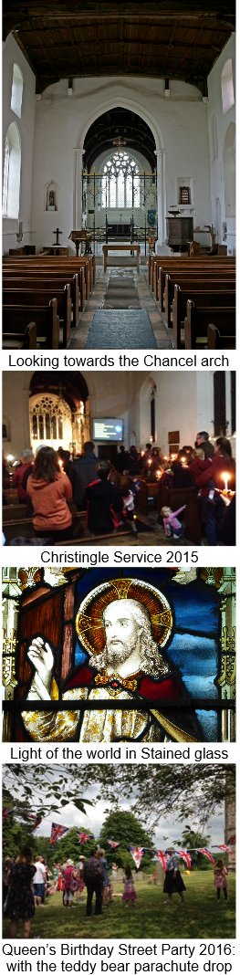Colville have joint services at Christmas, alternating as the location for midnight mass and Christmas morning from year to year. On the fifth Sunday, there is a united benefice service, which takes place by rotation in one church in the benefice.

**Our mission**

St Andrew’s has a small but committed congregation, which we are keen to see grow. There are many inhabitants of West Wratting who already contribute to supporting the life of the church as a community and building without attending services. We are eager to encourage and strengthen ties with the rest of the community through events and initiatives that bring together church goers and non-church goers. We want to make St Andrew’s increasingly inclusive. We strongly support the Parish Nurse Project, which we regard as central to creating a caring and compassionate community.

Members of the congregation would like to see existing services maintained, but we also hope to introduce different styles of service to meet the needs of a wider range of people within the community, notably families with children, who find the traditional liturgy intimidating. We want the church to embrace all age and social groups (including disabled people) and strengths of belief. This may involve a creative reconfiguration and use of the church space, and in particular the chancel. We are also keen to reinstate a monthly Family Service and some would like to see the introduction of evening and Sunday afternoon discussions. We would be open to the church being used for services by other denominations. We hope that the new incumbent will help us to engage in outreach initiatives to assist the church to grow.

**Our structure**

We have two churchwardens (Sebastian Bain and Alex Walsham) and an electoral roll of 35**.** There are six members of the PCC (including the churchwardens) and they meet five times a year. We have a rota of laypeople for the setting up of the service and serving coffee afterwards, as well as for cleaning and flower arranging. We have an organist who supports all our services. We have an active group of bell-ringers, who ring each Sunday, led by the tower captain, Dr Mike Rowland.

**Our building**

The oldest part of the church dates from the fourteenth century and changes were made in the fifteenth century. The church was heavily restored in the eighteenth century and further remodelling took place in the nineteenth century. The church has a fine ironwork screen that dates from 1922. The organ was built in 1895 and enlarged in 1953, when it was moved to its present position. It was recently repaired with the assistance of a grant from the Wadlow Wind Farm Community Fund. The Church has six bells. The church seats 120 in the pews, but can seat up to about 250 if chairs are put out in the chancel and other areas. The church has an oil-fired heating system. There is 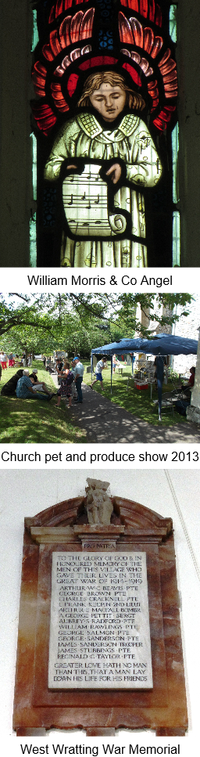a kitchen in the area under the tower.

In April 2016, St Andrew’s was the victim of the theft of two thirds of its roof lead. This catalysed a vigorous fund raising campaign to replace the roof with steel led by the PCC and assisted by other villagers, who have been immensely generous with their time and support. Our misfortune has been reported in local newspapers and also featured on ITV Anglia news. We have secured grants from a number of charitable trusts and benefited from generous donations from local people. Happily, the works to repair the roof and the damage to the interior are now underway. These began in January 2017 and will be followed by redecoration of the nave and chancel. The last Quinquennial inspection took place in October 2016 and revealed no serious issues requiring urgent attention, once the roof repair is complete. We also have plans to improve disabled access to the church and to install a toilet to enable the building to be used for a variety of purposes by the whole community.

A team of volunteers, led by Cobby McCall, keeps the churchyard in excellent order. The grass is regularly mown and there is a twice yearly working party to prune trees, remove ivy, and tidy gravestones, accompanied by coffee and doughnuts. Burials still take place in the churchyard.

A recent meeting to which the whole village was invited elicited some excellent ideas for utilising the building and churchyard for other activities, including flower arranging courses, a community orchard, farmers’ market, remembrance garden, youth groups, camping, cooking and wildlife classes, and a mini sports day.

The Vicarage in West Wratting was built in 1971 and has been used as a residence for the House for Duty Priest in the past. It is currently occupied by tenants.