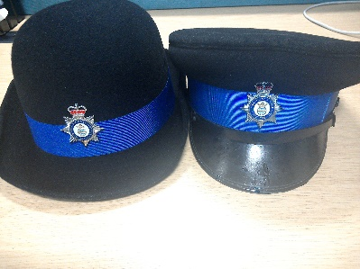****

**West Wratting Crime Prevention Event**

**OP HUNTER**

**Wednesday**

**8th Nov. 2017**

**Between**

**5.00 pm and 7.30 pm**

**West Wratting Village Hall, 79 High Street, West Wratting, Cambridge, CB21 5LU**

**Cambridgeshire Constabulary invites you to come along to meet your local policing team and receive security advice on how to protect your home.**

**Home security products for sale and the chance to get a free home security survey.**

**In partnership with Balsham Parish council and Neighbourhood watch.**