**Annual Report**

**St Andrew’s West Wratting**

**For the year 2016**

**Annual Meeting**

**12th March 2017**

**11.45 am**

**St Andrew’s Parish Church, West Wratting**

### St Andrew’s Church, West Wratting– Annual Report of the Parochial Church Council for the Year Ended 31 December 2016

#### Administrative information

St Andrew’s Church in West Wratting is part of the Diocese of Ely within the Church of England. The correspondence address is 25, High Street, West Wratting CB21 5LU.

The Parochial Church Council (PCC) is a charity excepted from registration with the Charity Commission.

PCC Members who have served from 1 January 2016 until the Annual Church Meeting in 2017 are:

*Honorary Associate Priest*: Very Revd Keith Johnson

*Warden:* Prof Alexandra Walsham

*Warden*: Mr Sebastian Bain

*Secretary*: Mrs Linda Gorman

*Representative on the Deanery Synod*:

Mrs Jeanette Job

*Elected Members*: Mrs Jeanette Job (Ass’t Church Warden)

Mr Simon Sampson

Mrs Catherine Willcocks (Ass’t Church Warden)

Treasurer: Mr Gary Birditt

#### Structure, governance and management

The method of appointment of PCC members is set out in the Church Representation Rules. All Church attendees are encouraged to register on the Electoral Roll and stand for election to the PCC.

#### Objectives and activities

St Andrew’s Church, West Wratting PCC has the responsibility of cooperating with the Priest in Charge in promoting in the ecclesiastical parish the whole mission of the Church, pastoral, evangelistic, social and ecumenical. It also has maintenance responsibilities for the Church building, churchyard and surrounding areas bounded by St Andrew’s, West Wratting.

#### Achievements and performance

#### Church attendance

There are 31 parishioners on the Church Electoral Roll. The average weekly attendance in 2016 was 15 adults. This number increased significantly at festivals and the four Songs of Praise services held each year, some of which attracted as many as 70 people. Other services that were well attended were the Christingle, Christmas Carol service and the Crib service held on Christmas Eve.

#### Review of the year. The Secretary’s report of the PCC

The PCC met 8 times during the year including two joint meetings. The main subjects of discussion were the upkeep of the fabric of the church, repair of the Nave roof after the theft of the lead and the process of appointing a New Priest to the 6 parishes that we are jointly combined with.

The members of the Standing Committee during the year were Linda Gorman, Alex Walsham, Jeanette Job, Catherine Willcocks, Sebastian Bain and Simon Sampson.

The pattern of regular worship during the year was unchanged. Communion services are held on all Sundays other than when we celebrate with members of all ages in a “Songs of Praise” service four or five times year. A Communion service on the fifth Sunday of the month was shared with parishes in the Abingtons, Hildersham and Balsham benefices. This pattern was sustained thanks to the careful stewardship of Revd Dr Julie Norris until she retired in (14th August 2016), and The Revd Canon John Fellows (last service 17th April 2016). Throughout the year the support of Very Revd Keith Johnson (retired), Revd Kathy Bishop (Associate Priest), Revd Dr Carrie Pemberton-Ford, The Ven Alex Hughes, Revd John Pinder, Keith Day and LLM Steven Wheeler all share the services.

The Benefice Lent course in 2016 was titled “the Mystery of Everything” with the showing of the film “The Theory of Everything” starting on the 7th February at Hildersham Church and following on weekly at The Black Bull public house in Balsham and Hildersham Church.

We are grateful to Mrs J Romanis for her most valued contribution to St Andrew’s services as our Organist. We thank her sincerely.

**Services**

Since the retirement of John Fellows, our House for Duty priest, and the unexpected resignation of our Priest, Julie Norris and her subsequent departure in August, we have been served very loyally by a variety of clergy, to whom we are very thankful.

Firstly our thanks must go to Julie and we wish her happiness in her new role, but especially also to Keith Johnson and Kathy Bishop who, between them, have taken most of the services in West Wratting, certainly since August. Thanks also must go to The Archdeacon, Alex Hughes, who is very involved in finding us replacement clergy, and has taken services, to Carrie Pemberton-Ford, and John Pinder, and lastly to Keith Day, who came to play the organ at a service and found himself conducting the service as a lay reader, when one of the stand-in clergy failed to arrive due to a mix-up.

For the popular Songs of Praise we extend our thanks to John and Scilla Harvey for leading and arranging the services which we have held for the last few years – the team that supports the service are a key to the success – many thanks to them, in particular the music team who have been drawn from Rock Road Baptist Church, Linton Free Church and Christ Church Trumpington, all who have provided musicians. Also we would like to single out Ross Jones and his family who have all contributed, but especially Ross himself as he has done the talks brilliantly for the children (of all ages). Helene Evans also gave a talk about a link with a Liberian church to which we had previously sent baby clothes. The children there had sent a long banner which we displayed as a 'thank you'.

**Looking to the future**

NOTES OF MEETING TO DISCUSS FUTURE OF & IDEAS FOR USE OF ST ANDREW’S, WEST WRATTING

Sunday 6th November 2016 at 4 pm

Despite the bad weather, about 20 people came to this gathering, including a number of people who do not normally attend church. After everyone had had tea & cake, Alex invited everyone to take a seat and outlined the four main purposes of the meeting:

1. A social gathering
2. To give an update on fundraising
3. To get ideas of way to make the church more central to the village – what uses the building could be put to
4. Ideas for the kinds of services that could be held, in particular, during the vacancy. The process to fill this is under way but could take some time.

Alex Walsham then drew the meeting to a close, thanking everyone for coming and saying how helpful it had been.

We need to make the church more of a hub for the community at large, as well as church goers. Before the theft of the lead, the plan was to provide a toilet and better disabled access to make the building more useful. This will be our next priority. We need suggestions for other groups and activities which could take place in the church.

Alex then handed over the meeting to Jeanette who asked for paper in three colours be passed out to everyone and then appointed 4 team leaders, by the intriguing process of working out who had used certain mugs to drink from.

Everyone was then asked to put down their ideas for uses for the church according to the arbitrary colour of the paper they had been handed, in 3 categories: financial, community, and services and other activities. This included the grounds.

Ideas to raise money included solar panels, using the church for filming and organ recitals. Some ideas discussed by those who attended the Saturday café included erecting a phone mast and renting the church for music recordings (e.g. The Clerks’ Group led by Lionel Wickham’s son, Edward, who came from London to record in St Andrew’s).

Services suggested included a Pet service, mattins, evensong, as well as the continuation of Song of Praise services, prayer book morning service, such as the informal one that Keith Day hosted last month. Family and child friendly services were a priority. It was commented that some adults were themselves intimidated by traditional services, especially when it was assumed that they knew the order of prayers and when to stand and sit. The layout of the church was thought to be not “user friendly”. Mike Rowland argued enthusiastically for a rearrangement of the Chancel so that it could be used for regular services and others strongly supported this view. It was more versatile, welcoming and cosy (and easier to heat). The church chairs from the Village Hall could be used for this. It was suggested that a keyboard might be used for some services instead of organ. Someone suggested twinning with other churches. Others thought that talks on different subjects would be attractive, including evening and late Sunday afternoon discussion services. Another idea was using the church for an Alpha style course for enquiring minds. More John and Scilla type family services were thought to be desirable; and someone from STAG has expressed an interest in coming to talk, too. The possibility of the building being used for Catholic Church services, or Methodist, perhaps once a month, was also aired, and this could perhaps be extended to other denominations.

Further ideas for the use of the church and churchyard included a jazz choir for the benefice, ethics discussions, flower arranging courses, community orchard (perhaps making our own cider), farmers’ market, Remembrance garden, youth groups, a mini sports day, camping, cooking, and wildlife classes. It was also suggested that we could hold over-60s picnics under cherry trees. Its use for play and toddler groups was also a possibility. There might be church parades, links with local villages, affiliations with local schools and societies, e.g. the Linton History Society?), and WI type speakers. Mike reminded the meeting that this is a church and, while we wanted it to be community friendly, we do have a village hall with better facilities for some of the suggested events. At the least a disabled toilet is required.

**Alex Walsham**

**Sunday, 6th November 2016**

**Songs of Praise 2016**

During the year four Song of Praise services have been held. An important aim in holding these services has been to attract families from the village, especially those who don’t regularly attend. The numbers have typically been in excess of 70 and a very high proportion of those attending have come from the local village community. For each service a lively contemporary format has been followed with the music being led by a group drawn from Rock Baptist Church in Cambridge and Linton Free Church. These services have been kept child-friendly and young people have been encouraged to participate with readings and in other ways. A short talk has been included each time aimed at the children - but intended to be equally relevant to the adults. In March the theme was appropriate for Palm Sunday/Easter with a link to children in a Liberian church and in June the focus was on the Queen’s 90th birthday celebration. October’s concentrated on the Harvest and included an appeal for the Syrian Refugees. In December it was a Christingle service when 90 attended. These Songs of Praise services have been well publicised including a leaflet distribution to houses in the village and at all of them there has been a very good community feeling with the congregation staying on to chat over tea and cakes afterwards.

**John & Scilla Harvey**

**Bell Ringing Report of the year 2016**

I am pleased to report that we have another talented and committed new recruit, Clive Parry, who has joined our band of ringers in West Wratting. Thursday evening practice nights are well attended, being both challenging and enjoyable. In this respect we continue to be indebted to our regular, more experienced mentors from other towers in the district.

Our bells remain popular with visiting bands, of which there were 8 last year, and for occasional district advanced Friday practice nights. These activities bring a modest but useful income to supplement our Millennium Bell Fund. This is important as there are always outgoings for maintenance of the bells, and recently for rope replacements and repairs. For this reason we have not made a donation to the church this year.

We hope our service ringing is generally appreciated – I only get to hear the positive comments!

**Mike Rowland**

**Tower Captain**

**Charities supported during the year**

We have supported Children in Need, the Royal British Legion, the Parkinson Society, Leprosy Mission and the Syrian Refugees, as well as raising £200 for the Tearfund.

**Fabric Report**

#### St Andrew’s Churchyard

The Churchyard continues to be maintained to a high standard, thanks to an army of volunteers.

The autumn and spring clear-ups are well attended and make a huge impact on the churchyard's overall looks, while Andrew Waygood does a yearly cut of the wild bits in September. The summer grass cutting is carried out by a dedicated gang of mowers - Ben Willcocks, Simon Sampson, Pete Rendell and Kevin Brown, who make the churchyard look immaculate.

The damson trees at the East of the churchyard are in the process of being coppiced, as they are beginning to rot from the top and are becoming dangerous. This will allow their sapling 'children' to get lighter, and hopefully grow evenly.

Eloise Gilley has collected cherry stones from the cherry trees in the churchyard and potted them with a view to perhaps replacing the older cherries in the years to come. The self-sown cherries - one among the South graves and one on the boundary to the East, have been spotted by Andrew Waygood and we are sowing these to grow.

For the record, over the past 18 years, the following trees have been planted: two laurels, two crown yews, six oaks, one copper beech, two ashes, one lime and two cherries. During that time, one large ash next to the tower was coppiced and is coming back strongly. Also, one diseased chestnut was taken down. However, there are four self-sown chestnuts in the same area, which will more than cover the tree taken down.

Many, many thanks to everyone who help to maintain our beautiful churchyard, both churchgoers and non-churchgoers alike. It is such a beautiful spot, and, along with the church itself, one of the jewels in West Wratting's crown

**Cobby McCall**

**The Roof**

Picture of the roof with its first temporary roof covering

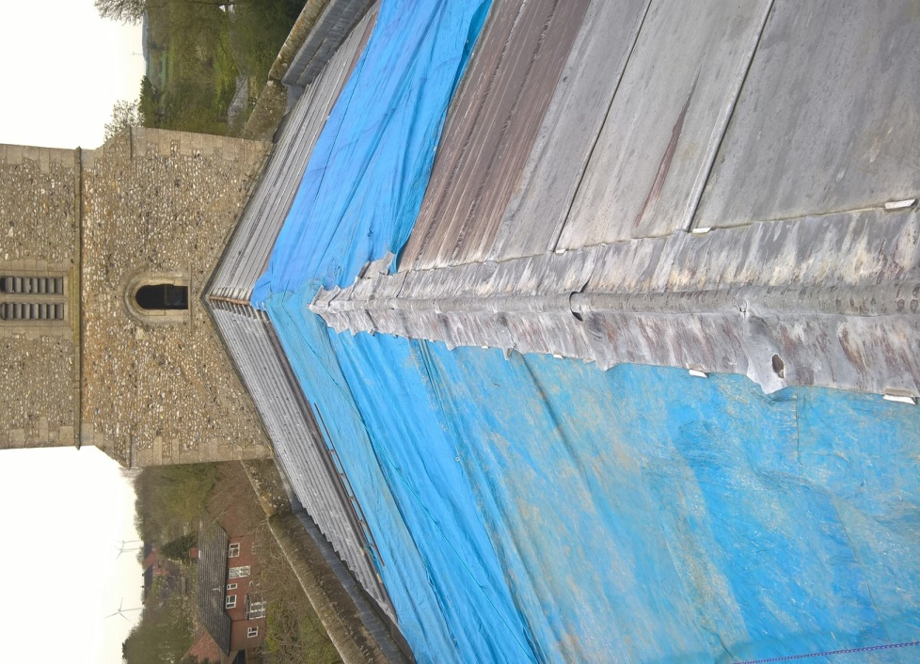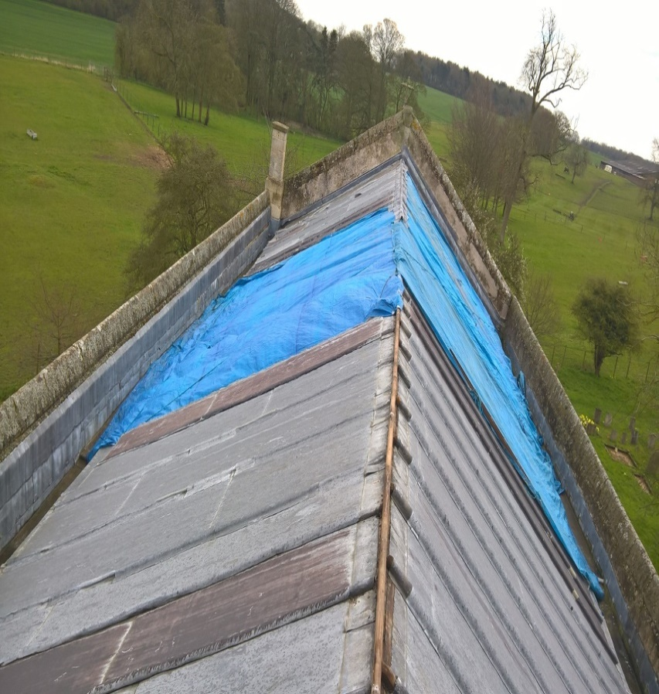

Following the theft of a large portion of lead from its roof in April, a group of brilliant volunteers put a temporary roof on. The temporary covering for the roof did in the main a great job in ensuring as little damage occurred to the fabric of the interior of the church - however there was near despair when water started pouring into the main body of the church, after the roof lead was stolen, but everyone soon rallied round, and Mark Addley arranged a tarpaulin, helped by Mick Lock, Ben Willcocks and others.

This temporary repair held up pretty well until July, when 75 mm of rain fell in just under two hours, and ominous brown stripes appeared on the North East side of the main body of the church

Again, everyone rallied round. Mark Addley regularly tightened the tarpaulin, while Linda Gorman and Cobby McCall placing buckets, vases and beer glasses strategically where the worst drips were experienced. We will look forward to having the Nave and the Chancel painted in the coming months so that it will all become a distant memory

Behind the scenes, the pcc roof team and the clergy team at the beginning of August secured consents from South Cambs and the Diocese to replace the missing lead with steel, and also the remaining lead. Quotes were also obtained for the building and redecoration works. This was the result of a lot of hard work from the West Wratting team and our thanks go to them for that.

Although some funds allocated over the years for fabric repairs are available the total costs are likely to be £100,000, including the redecoration. We must thank everyone who donated so generously to help us raise the funds to replace the church roof and redecorate the church! A team of individuals in the village also set to work to complete grant applications so that we could secure sizeable grant awards. We must give huge thanks to Diana Edwards and Catherine Willcocks for their invaluable help with these grant applications and also to Phil O’Donovan for his support and advice reviewing the necessary documentation. Also to everyone on the PCC who have worked tirelessly to make this happen.

Mark Addley and Phil O’Donovan are currently working hard to oversee the building works that are being completed and we thank them for all they are doing to help!

The church building is there for everyone to enjoy, and it is not simply a religious building: it is there for anyone to sit in, meet in, drop in and make a cup of coffee/ drink of squash, and to use for anything, such as exhibitions such as we have seen in the past with village history and war memories, through to pantomimes, concerts, displays on bell ringing, and anything else. We hope that with this work completed, it will stay open and alive for generations to come.

**The Church Interior**

In addition to our normal maintenance of the interior the key actions during the year were:

Suzanne Langford also undertook to polish all the brasses, which sparkled, come rain or shine. As ever, a huge thank you to everyone who cleans the church (it always looked spotless throughout our tribulations), our deep thanks to Fanny Peers, Jenny Knowelden, Sue Lock, Maggie Attewell and Pauline Hollness and the flower arrangers who bring joy to us with their fantastic displays, Frances Peers, Alex Walsham, Jenny Knowelden, Louise Sampson and Linda Gorman, our sincere thanks to you all.

Also, thank you to Ben Willcocks for looking after the central heating and the electrics, and Di Edwards for maintaining the fire extinguishers, and Mark Addley for looking after the roof gutters and the clock.

Suzanne very kindly donated the Christmas tree, which was decorated with the usual panache. Thank you, Suzanne.

We wish to thank everyone that helped to produce the St Andrew’s directory of contacts and sources of information, which is a very useful reference document for anyone needing information about who to go to.

A footnote: Recently, when the electrician was working in the church, we were standing in the sunshine outside, when his assistant looked at the sundial and said 'it's twenty past three'. We looked at our watches and so it was. So, if you want to adjust your watches forget about satellites and go down to the church. Sanneke Sole very generously paid the sundial's restoration and it now works!

The coffee and biscuits after the service are always a welcome time for us to chat and catch up on the week’s events – sincere thanks to everyone that supports this social part of the Service.

During the day the church is kept open for visitors to appreciate St Andrew’s many thanks to Sisse McCall for managing the rota and Sherry O’Donovan, Louise Sampson, Pamela Richardson, Barney Edwards, Margaret Potter, Maria and Kevin Brown, Di Edwards and Nicky and Chris Hodson for come whatever the weather to open up early in the morning and late in the evening, sincere thanks to you all.

#### Financial review and Treasurers report

**General Fund** voluntary income from gift aid donations was down to £10,742 from £12,017 in 2015, but this was mainly due to donations being specifically directed towards the roof. If we have written confirmation from individuals that they are tax payers we are able to recover 25% of the gifts given – this additional income is extremely important to us being over £10,650 for the past two years. Monthly Covenant giving during the year amounted to £7,180, it is the main stay to our income and this monthly income ensures we have a regular monthly cashflow to cover our outgoings – sincere thanks as this is truly appreciated. Income from weddings and funerals were considerable greater than 2015 at £2,909. Total Income for the year increasing by 5.5% to £16,746.

General fund expenses increased by £684 to £11,833 from £11,149 last year (+6.1%). Parish share was paid in full which increased from £8,333 to £8,422 in the year ending December 2016 (1.0%).

The fund raising raised £4,323 during the year, compared to £5,168 last year. The key success being the Clay Pigeon shoot raising £2,770 compared £1,975 the previous year.

The exceptionally successful fundraising for the roof repair during the year is summarised as

|  |  |
| --- | --- |
| Insurance claim | £15,000 |
| AS Charitable Trust | £6,000 |
| Wadlow Wind Farm | £10,000 |
| Nias Wheatley Trust | £2,000 |
| Personal donations | £18,120 |
| Interest | £6 |
| **Total** | **£51,126** |

(Note as at the time of writing with the Amey grant of £40K included and restoration funds we have £105,000 available for roof repairs, decoration and important quinquennial repairs - plus an interest free Loan facility of £20,000 from the Cambridge Historic Churches Trust)

Excluding the Roof repair funds - Funds increased at the year end from £24,462 to £29,538, of which £13,854 is restricted to church restoration.

Our first fund raising event was a concert arranged by the Balsham Singers who generously gave up their evening to support us, they were lead by their conductor and choirmaster John Clenaghan. We are indebted to them and the sincerest of offers of help in starting the fund raising.

We are also so very indebted to the many individuals who have so generously donated to our urgent repair needs and to the Grants received from Cambridgeshire Community Foundation Wadlow Wind Farm, Amey Community Fund, Cambridgeshire Historic Churches Fund, NIAS Wheatley Charitable Trust and the AS Charitable Trust

**Gary Birditt**

**Treasurer**

**Fund Raising Events**

Church events during the year were again a great success and all the organisers are to be congratulated. The total funds raised during the year were £4,323 (£5,168) from events such as the August Clay Shoot, and the West Wratting Concert held in Balsham and the harvest supper.

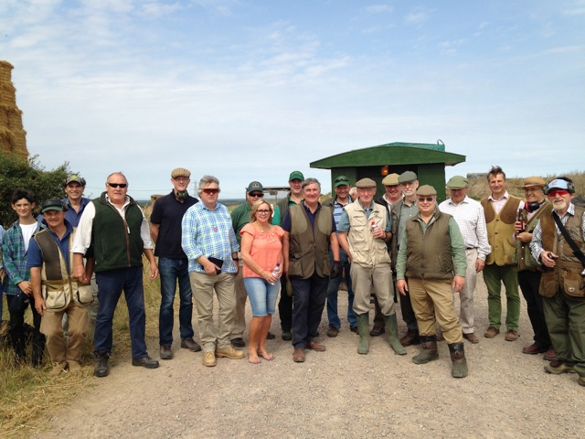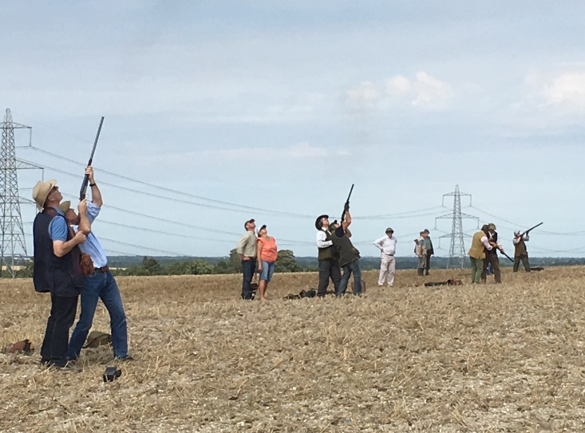

On 8 October 2016, the now-regular Autumn Charity Concert in aid of the St. Andrews Church Restoration Fund, was held in Holy Trinity Church, Balsham. This was the sixth event in this series. Support and sponsorship was forthcoming from eight different organisations and companies. We hosted a wide range of instrumental and choral performances, some of whom were established favourites and others new to our event. Despite somewhat reduced attendance, the useful sum of c. £600 was raised for St. Andrews. The next event in the series is planned for October 2017, and it is hoped that, in view of the improvements and renovations in St. Andrews, the event will be held there as opposed to the previous venue of Holy Trinity, Balsham.

We thank Jeanette Job, Michael and Linda Gorman and Simon Sampson for organising these events and their teams of helpers who made them happen.

**Challenge**

We must yet again thank our stoical editor of Challenge, Anne Bragg, for all the extreme hard work she puts into collating all the editorial, news and advertisements. This is no mean task and our villages are much indebted to her and to those who deliver the copies to over 450 households. I am sure everyone will agree that the monthly magazine is invaluable to all of us, and so is Anne!

**Frances Peers**

**The 7 Parishes Choir**

The choir was formed in 2014 by the merger of the Abington and Hildersham Choir with the’ Four Churches Choir’ and since then, to my great pleasure has really gone from strength to strength. The choir is a prime example of what we can achieve across our parishes when we ignore traditional boundaries and pool the considerable talent available to us.

The choir has an average membership of 18 singers, drawn from all the churches, and members have shown considerable commitment by meeting regularly each week for practice. The aim of the choir is to enhance and lead worship by making a joyful song to God, to improve the standard of our singing and, very importantly to have fun in doing so which I think we do. I am proud of the achievements of our choir and most grateful to them for what they do.

The choir have sung at each of the United Services in the parishes as well as at a number of special services including the Stations of the Cross in Balsham, a celebration of Magna Carta in West Wickham, the Nine Lessons and Carols Festival in Hildersham to name some but not all, they have also been pleased to perform in the annual concert in aid of St. Andrew’s, West Wratting. I would welcome other suggestions as to services or occasions where the presence of the choir would be welcome.

The choir have been delighted to form a relationship with the Sampfords Singers from North Essex who supported us a major service in Balsham and we shall be joining with them again through the year both on their territory and on ours.

Anyone who enjoys singing in church and is willing to commit to practice is welcome in the choir -there are no auditions and no requirement to read music but you must be willing to have fun singing. Practice is held on Monday 19.15 – 20.30 in Holy Trinity, Hildersham – do please contact me or any choir member if you would like to know more.

**Keith Day**

**01223 891527**

**keithdday@btinternet.com**

**The Parish Nurse**

**Meeting an unmet need**

From her appointment in December 2015 and commissioning by Bishop David in January 2016, Parish Nurse Teresa Letimier was constantly active in establishing parish nursing in our villages and in meeting a hitherto unmet need by receiving an average of eight contacts each working day.

The huge success of the launch of the Parish Nurse project was very much due to the commitment, care, determination and love shown by Teresa who played a huge part in turning our dream into reality and it is hard to find words adequate to describe our admiration and gratitude for what she was able to achieve in such a short time. Sadly as you know, personal circumstances made it necessary for Teresa to leave us but she left a legacy we shall value for a very long time.

Following Teresa departure we were hugely grateful to Claire Gillett from Parish Nursing Ministries UK (PNMUK) who offered to fill our vacancy until other arrangements could be made and in Claire’s capable hands the service has continued to grow and develop – we are so very much in her debt.

Teresa and Claire have seen clients of all ages from under one year old to over 95. Some clients have required only one visit while others have needed up to 28 face to face contacts; referrals have been from potential clients themselves, professionals and members of the village communities. Reasons for referral have been wide and varied including; people home from hospital, people feeling anxious, people facing operations, people needing help regarding caring – nothing is too trivial if it is a cause of real concern.

The range of task undertaken by the Parish Nurse is as wide as the reasons for referral and include; medicines management, advocacy with other services, help with forms, reassurance, help with care packages and, most important of all, listening.

In January of this year we underwent our first quality assurance visit by the Chief Executive of PNMUK and were delighted to be granted full accreditation – the service has now achieved its majority thanks to the huge efforts of our nurses and of the Management Group who work behind the scenes to ensure things run smoothly – I am most grateful to them all.

**Keith Day**

**26th February 2017**

**Granta Deanery Synod Report for 2016**

Deanery Synod met in April at St. Mary the Virgin, Sawston, in July at All Saints, Horseheath and in September and November at Holy Trinity, Hildersham. Parish Treasurers were invited to the July and September meetings.

Much time at the first 3 sessions was devoted to discussion and debate on the Ely Diocesan proposals for a new formula to allocate Ministry shares in 2017 and beyond. A 3% increase in Deanery Share and approval of the proposed Diocesan Budget for 2017 was eventually agreed, although great concern was expressed for smaller rural parishes with declining congregations. The Diocesan budget was based on higher numbers of clergy, wider clergy costs, population growth and investment in the future. Some of our parishes are already struggling and having to dip into reserves. Ministry shares will be calculated for each Parish and updated every year with shared costs allocated by the number of clergy posts. Increases will be stepped over 5 years to meet the target share. Unfortunately the present vacancy in our Benefice does not reduce our Parish share.

At the April meeting Ally Barrett, tutor at Westcott House, gave a presentation on a national Baptism project based on 3 themes: contract, build, care. The church has contact with 200,000 people per week through Baptisms. It needs to reflect changing trends around the celebration of birth, become involved earlier in the process and take positive action to encourage a continued sense of belonging. She recommended several websites, eg., *ChurchofEnglandchristening.org* and her book "Making the most of your child's Baptism" (SPCK).

Liz Megson described her work with Tanzania Link. Tanzania is 26th poorest country in the world and most of its people are subsistence farmers. It is developing rapidly with progress in education and medical provision. The Church is growing and 2 Tanzanian parishes would like to link with parishes here. St. Andrews, Stapleford, is already linked (*www.stapleford/nachingwea.org*). and supports its link village by sponsoring secondary education for some girls and seminars for medical staff.

In July, Rev. Julie Norris chaired her last meeting as Rural Dean. She said it had been a privilege to serve for the past 5 years developing the Mission Action Plan and working with clergy and colleagues. Treasurer, Bob Doel, thanked her for the conscientious way she had fulfilled her role, presented her with a small gift and wished her well in her new project. In September, Rev. Simon Talbott (Great Shelford) was welcomed as the new Rural Dean. He had previously been an Area Dean in N. Yorkshire.

At the September meeting, Jenny Duke explained her wish to set up a project for children 9-13 years. She had begun discussions with Ely Diocese and Youth for Christ about youth work possibilities at Deanery level and beyond, eg., How to help 9-13 year olds continue their Christian journey. Hinkledux would start a pilot project and after consultation with parents and children, 3 trial sessions were planned. The project team requested £1000 from Deanery funds which was agreed. In December a YFC youth worker was to help plan 3 further sessions linking Hinkledux with other parishes, building on current practice, eg., Cafe church, arts and crafts day, church youth council. Representatives from other Parishes with children in this age group should contact Jenny Duke or Rev. Simon Talbott.

At the November meeting Rob Needle, Manager of The Children's Society Shop in Sawston and Diocesan Ambassador for the Children's Society, told us about the charity's work with disadvantaged children in England and Wales, especially the 10-18 age group. It supports children who run away from home, young carers and young refugees, and campaigns for changes in policy, eg., young asylum seekers to be treated as children; free school meals for Key Stage1 pupils; breathing space for people in debt. Bishop Stephen sees the work of the Children's Society as a social justice issue and is keen to have beacon churches (like St. Andrews, Stapleford). Rob encouraged us to "pray, act, give"; to consider volunteering to help in the shops or with campaigns, box collections and Christingle services. A short film showed examples of children suffering abuse, mental health issues and hardship. The Children's Society works to help these children flourish.

The Deanery Spring Fair in March raised £1340 for local parish development funding. Bob Doel thanked all Parishes for meeting their Deanery share in 2016.

**Marilyn Broadhurst**

**Deanery Representative for the Abington Parish, March 2017**

**Revd Dr Julie Norris**

The PCC and congregation would like to offer very sincere thanks to Revd Julie Norris for her devoted ministry over the past seven years. Julie was encouraged by both of our Diocesan bishops to take an eighteen month sabbatical to write a book which our national church needs urgently. Julie’s doctorate was on the topic of the ethics linked to advances in medical research, and she was asked to go to the next stage and write a book on the same subject. New medical procedures are being announced on a regular basis, and there is a need for careful study about their use. Will they be used in a way that is acceptable? There will be a whole range of similar questions that need much thought and careful answers. Julie’s legacy included spearheading the project to appoint a Parish Nurse, and the adoption of the policy of Ely Diocese to make every parish church open and equipped for the use of the surrounding community. Under Julie’s leadership three of our seven churches, Hildersham, West Wickham, and Great Abington have already been converted for use in this way, with toilets and kitchen facilities. The plans for Balsham include constructing a Parish Room at the west end with toilets, and the funding for this is also almost complete. Weston Colville church has had a new nave floor, opening the church up for community use, and a new heating system for the chancel.

**Thank you**

The Very Revd Keith Johnson, on behalf of the Rural Dean, the Revd Simon Talbott and the members of the Ministry Team thank Alex Walsham and Sebastian Bain for their hard work as Church Wardens and Catherine Willocks and Jeanette Job for acting as assistant Church Wardens. Gary Birditt for his dedication and advice as Treasurer, Linda Gorman as Secretary, Ian Creek for acting as the independent auditor and the members of the PCC for their continual endeavours, the many individuals that ensured we had flowers through the year and cleaned and polished the church so beautifully. Ensuring that everything is tidy in the Church and the graveyard, Sisse McCall for ensuring the rota for opening and closing the church to ensure we keep our church open and also to everyone for their practical support in getting things done on so many levels and of course to those who have set up for services and those who have provided the refreshments. Many thanks to Jenny Knowelden for her role as sacristan. This is not just the same story as in last year’s report all of the above have continued to serve in their respective roles through nine months of the current interregnum. And in addition to this, everyone at St. Andrew’s has had to cope with the impact of the theft of lead from the church roof last April. We must congratulate the team that safeguarded the roof and in particular Mark Addley, who has ensured the roof has been physically safeguarded against the elements since the theft of the Lead. A magnificent fund-raising effort has been managed by the PCC and individuals within the village, we are truly blessed, and the generosity of individuals within the village and even from far afield is truly appreciated. The Support of The Wadlow Wind Farm, CHTC and Amey has ensured we can start the repairs and ensure we have made St Andrew’s stronger for future generations.

Finally, a word of thanks to all those in the village who have once again played their part in making last year such a full and productive one for St Andrew’s.

**The Very Revd Keith Johnson**

**March 2017**

**MINUTES OF THE ANNUAL PAROCHIAL CHURCH COUNCIL MEETING OF THE PARISH OF ST ANDREW’S, WEST WRATTING**

**Held in St Andrew’s**

**On Monday 11th April 2016 at 7.30 pm**

**MEETING OF PARISHIONERS TO ELECT CHURCHWARDENS**

|  |  |  |  |  |
| --- | --- | --- | --- | --- |
|  | |  | | **ACTION** |
| **1.**  **2.**  **3.**  **4.**  **5.**  **6.**  **1.**  **2.** | | Rev Julie Norris extended a warm welcome to everyone and, in particular, the Archdeacon, the Venerable Alex Hughes and Very Rev. Keith Johnson.  Julie also briefly outlined the position re the roof after the lead theft. The loss adjustors had been and had asked for three quotes and the architect would be coming. We are expecting the quotes to be obtained on Tuesday. The present need is to make the roof watertight and a decision about replacement of the lead would be discussed and made in due course.  Revd Canon John Fellows opened the meeting with prayers.  **apologies for Absence**  Apologies were received from Mr Gary Birditt (Treasurer), Prof. Alex Walsham, Mrs Jennifer Knowelden  **MINUTES OF THE LAST MEETING**  The minutes of the Annual Meeting held on Monday 27th April 2015 were approved and signed as a correct record of the proceedings.  **Matters arising**  There were no matters arising  **Election of Churchwardens**  There was one submission for election of Churchwarden – John J S Bain, who had been proposed and seconded. It was formally put to the vote and unanimously supported that Sebastian Bain should be re-elected for the coming year.  Julie Norris thanked Sebastian for continuing despite his work and those who helped and shared the load.  The meeting was then closed.  **ANNUAL PAROCHIAL CHURCH MEETING**  All were welcomed  **apologies for Absence**  Apologies were received from Mr Gary Birditt (Treasurer), Prof. Alex Walsham, Mrs Jennifer Knowelden | |  |
| **3.** | | **MINUTES OF THE LAST MEETING**  The minutes of the Annual Meeting held on Monday 27th April 2015, having been made available, were approved and signed as a correct record of the proceedings. | |  |
| **4.** | | **MATTERS ARISING**  There were no matters arising. | |  |
| **5.** | | **THE REPORTS**  **Priest in Charge Report**  Julie directed people to the report which had been circulated and confirmed that the wedding that took place in West Wratting would be added. John was again thanked and received a card from Keith Johnson. There had been a lot of work across the parishes, in particular relating to the Parish Nurse. Julie was grateful to all those in West Wratting who had helped this happen.  **Electoral Roll**  Simon Sampson confirmed that the numbers on the Electoral Roll had gone up from 31 to 33. It was believed that next year this would have to be gone through in detail.  **Annual Report of the PCC**  The Annual Report of the PCC had been circulated to all those on the Electoral Roll. Details of the activities and work were set out in the Annual report of the PCC. Julie thanked Linda Gorman for her input  **Report of the Financial Statement of the PCC for the year ended 31st December 2015**  Until the lead theft, we were in a better position but we now had a lot of fundraising to do. The insurance only gives limited liability for metal theft. Catherine Willcocks asked if the insurance would cover us again and there was some discussion about what material would be used to replace it such as turned stainless steel. Raymond Maskell asked about slates but Julie felt that this would not be feasible. Keith commented that the steel had been used at a church in Royston and it was fine. In response to a query from Cobby McCall it was stated that funds had increased from £17, 341 in 2014 to £24,262 for 2015.  Julie Norris thanked Gary Birditt for his work on the accounts for which we were very grateful and to Sebastian Bain and Phil O’Donovan for their work on the Parish Share, including attending meetings on our behalf.  The accounts were then formally adopted.  **Report on the Goods, Fabric and Ornaments of the Church**  Fanny raised the work that Pat Copeman and Cobby McCall had done, in particular all the painting and Cobby for the donation of a new hoover which had made cleaning the church a pleasure. All agreed that they deserved our thanks. Julie thanked all who had been involved in redoing the children’s corner and tidying the church. John thanked Suzanne Langford for tidying the Vestry and Linda added that she had also tidied the flower arranging cupboard for which she was very grateful.  **Report of the Bell Ringers**  The report of the Bell Ringers had been circulated. Julie thanked Mike Rowland and the other bell ringers, particularly for stepping in to help other teams.  **Report from the Deanery Synod**  Julie Norris thanked Phil O’Donovan and Sebastian for their work relating to this and for attending meetings. | |  |
| **6.** | | | **ELECTIONS AND APPOINTMENTS**  Julie thanked the PCC for all their work over the past year. As Sherry O’Donovan was standing down from the PCC, she was presented with a card and a rose bush. John pointed out that she had been an important bridge between the church and rest of the community. (At this point as the rain was coming through the roof, it was decided to move first to the back of the church and then to the Chancel) John was moved to ask if we had to wait for the roof to be dealt with. Sebastian reassured everyone that we would be getting quotes on Tuesday and a temporary cover could be put on very shortly.  Proposed Lay Parochial Church Members were Linda Gorman, Jeanette Job, Simon Sampson, Alex Walsham and Catherine Willcocks. These were proposed, seconded and accepted.  Thanks were given to all the sidesmen. Mrs Jenny Knowelden, Mr Colin McCall and Mrs Sisse McCall, Mr Ben Willcocks, Prof Alex Walsham and Mrs Frances Peers were re-appointed. Mrs Eva Mathews was removed from the list as she was now unable to carry out this duty.  Sebastian Bain was re-elected as our Deanery Synod representative to be helped by Phil O’Donovan. |  |
| **7.** | | | **APPOINTMENT OF INDEPENDENT EXAMINER OF ACCOUNTS** |  |
|  | Thanks were given to Ian Creek. It was agreed that he be re-appointed for the next year. | | |  |
| **8.** | **DEPLOYMENT OF MINISTRY**  The Venerable Alex Hughes introduced this discussion. He referred to the article that had been published in Challenge after which he had already heard from some people. He wanted to discuss how to help himself and Julie to go forward.  The ideal would be to have a priest in every community but this is not possible because of the shortage and the church could not afford it. It is commonplace to have no resident parish priest.  Sisse McCall pointed out that the parishes had not been informed of the decision made four years ago about the House for Duty post. Alex Hughes responded that for the two years he has been in post, and so is the time he had known about the proposals and the expectation that this is what would happen and it was unfortunate that this was not widely known. He felt that Julie would be better able to comment.  Raymond interposed that few people knew and asked how it was promulgated.  Julie responded that there was a need to recognise that the post here had been changed from full time to half time.  When Julie was appointed someone to work with a bigger group was needed with one person looking after the Abingtons etc and one for the Balsham benefice.  There was a big discussion with Balsham. The agreement pre-dates Julie’s appointment.  Raymond Maskell commented that there had been a lack of communication.  Cobby was very troubled by the paper that had been issued prior to the meeting with Archdeacon and felt that it contained many inaccuracies. There was a lot going on in the two parishes. It stated that we had only paid £8,000 Parish share but this put us at number 2 in the amount paid per capita. It is currently a thriving community and there was a need to rewrite the document.  Alex Hughes was pleased to hear what Sebastian Bain was saying and asked to be given points that it was felt should be changed in the recommendation. A concrete proposal was needed and, when the application process was run, points to be taken into consideration.  Fanny suggested that the most important thing at the moment was to get the roof fixed. Alex responded that he could hear her frustration and it was not an easy situation. There is nothing yet set in stone and no job description has been produced yet. He will be asked by the Bishop for his recommendations in consultation with Julie and this will be discussed at the meeting of the Archdeaconry Mission and Pastoral Committee.  There is obviously support for the flourishing community spoken of by Cobby McCall.  Sue Lock added that it was important to get the history correct and what has been happening over the last few years in relation to the job description.  The document as it is which is for internal use should not go on file as is.  Julie paid tribute to what John Fellows had done. We had difficulty paying the Parish Share. John said that there had been a lot of good work and giving.  Jeanette Job pointed out that John’s accessibility had been key rather than it being just an isolated building and had appealed to a wider group than just church goers. If someone is not living there it will be difficult to share. Is there going to be a specific time when someone will be in the village for people to discuss problems and other matters?  Alex responded that he got the point and there are a variety of models for example a surgery once or twice a week.  Julie said that there are plans for morning prayers amongst others. Jeanette raised the possibility of Evensong which other people also supported. Ideas should be passed to Julie.  It was pointed out that non-religious people had been coming into the church to talk. It was agreed that it is a wonderful church for this. Another idea was a Sunday Compline and it was agreed that the Songs of Praise services are good.  Sisse called for more openness and inclusion of the congregation. Alex Hughes agreed that transparency was important.  Simon Sampson added that whoever the new person it is important that the atmosphere of the village is not degraded by any changes. Clergy need to be available and it is important for people locally to know who they can contact and how.  Alex said that there needed to be a positive welcome to new ministers.  Fanny Peers said that we were very lucky to have had John, and before him Keith Johnson and Michael Banner.  Cobby commented that this had all taken him two months to digest.  John said that although it was difficult for him to speak objectively it couldn’t be said that Weston Colville had not improved as much without someone living there. It is the visibility of the “shepherd” to the flock that enables this to happen.  Keith agreed that the same was true of West Wickham and Hildersham.  Sisse pointed out that the church is very much a part of the community which is important for the successful fundraising for the fabric of the church. Jeanette added that church goers are the minority for fundraising. The rest of the community are keen that the building is here when needed and they also do a lot of work in the churchyard.  Pat Copeman asked if there will be representatives from each parish at the Archdeaconry Mission and Pastoral Committee meeting. Alex explained that there would be limited to representatives from the Deaneries as there would be too many people to cope with. | | |  |
| **9.** | **CLOSING PRAYERS were said** | | |  |
|  |  | | |  |

**St Andrew’s, West Wratting**

**Annual Church Meeting**

**Sunday, 12th March 2017 at 11.45 am in St Andrew’s Church**

**AGENDAS**

**MEETING OF PARISIONERS TO ELECT CHURCHWARDENS**

1. Welcome The Ver *Revd Keith Johnson*
2. Opening prayers The Ver *Revd Keith Johnson*
3. Apologies for absence  *The Ver Revd Keith Jonson*
4. Minutes of the meeting of 12th March 2016/22nd Aug 2016
5. Matters Arising
6. Election of Churchwardens

**ANNUAL PAROCHIAL CHURCH MEETING**

1. Welcome *The Ver Revd Keith Johnson*
2. Apologies for absence
3. Minutes of the meeting of 12th March 2016 (IS THIS CORRECT DATE?)
4. Matters Arising
5. The Reports

* Church Wardens report
* Electoral Roll –
* Annual Report of the PCC -
* Report of the Financial statement of the PCC for the year ended 31st December 2016 Report on the Goods, Fabric and Ornaments of the Church
* Bell Ringer’s Report
* Report from the Deanery Synod

1. Elections and Appointments

* Election of Lay Parochial Church Council Members -
* Appointment of Sidesmen –
* Deanery Synod Representative -

1. Appointment of Independent Examiner of Accounts -
2. Interregnum – statement about where we are now.
3. Toilets, Disabled Access, and Possible Reorganisation of the Layout at the back of the Church
4. Closing Prayers.

**PCC MEETING**

1. Election of Treasurer and Secretary

2. Standing Committee

3. Date of Meetings:

18th May at 7.30 pm Joint PCC at Great Abington

(Date to be confirmed) July St Andrew’s Church 8pm

(Date to be confirmed) September St Andrew’s Church 8pm

*Apologies to Linda Gorman Tel:* 01223 290653 email: lcg3@btinternet.com

|  |  |  |  |  |  |  |  |  |  |  |  |
| --- | --- | --- | --- | --- | --- | --- | --- | --- | --- | --- | --- |
|  |  |  |  | **West Wratting Parochial Church Council** | | | | |  |  |  |
|  |  |  |  |  |  |  |  |  |  |  |  |
|  |  |  |  |  |  |  |  |  |  |  |  |
|  |  |  |  | Receipts & Payments Accounts | | | |  |  |  |  |
|  |  |  |  |  |  |  |  |  |  |  |  |
|  |  |  |  |  |  |  |  |  |  |  |  |
|  |  |  |  | For the Year ended 31st December 2016 | | | | |  |  |  |
|  |  |  |  |  |  |  |  |  |  |  |  |
|  |  |  |  |  |  |  |  |  |  |  |  |
|  |  |  |  |  |  |  |  |  |  |  |  |
|  |  |  |  |  |  |  |  |  |  |  |  |
|  |  |  |  |  |  |  |  |  |  |  |  |
|  |  |  |  |  |  |  |  |  |  |  |  |
|  |  |  |  |  |  |  |  |  |  |  |  |
|  |  |  |  |  |  |  |  |  |  |  |  |
|  |  |  |  | Contents |  |  |  |  |  |  |  |
|  |  |  |  | Page |  |  |  |  |  |  |  |
|  |  |  |  |  |  |  |  |  |  |  |  |
|  |  |  |  | 1 General Fund Account | |  |  |  |  |  |  |
|  |  |  |  |  |  |  |  |  |  |  |  |
|  |  |  |  | 2 Challenge Magazine Account | | | |  |  |  |  |
|  |  |  |  | Roof Account |  |  |  |  |  |  |  |
|  |  |  |  | Church Central Board of Finance Interest | | | | | |  |  |
|  |  |  |  |  |  |  |  |  |  |  |  |
|  |  |  |  | 3 Restoration Fund Account | | | |  |  |  |  |
|  |  |  |  |  |  |  |  |  |  |  |  |
|  |  |  |  | 4 Assets & Liabilities | |  |  |  |  |  |  |
|  |  |  |  | Bank Balances | |  |  |  |  |  |  |
|  |  |  |  | Summary of Receipts over Expenditure | | | | | |  |  |
|  |  |  |  | Debtors |  |  |  |  |  |  |  |
|  |  |  |  | Sundry Assets | |  |  |  |  |  |  |
|  |  |  |  | Sunday School Funds | | | |  |  |  |  |
|  |  |  |  |  |  |  |  |  |  |  |  |
|  |  |  |  |  |  |  |  |  |  |  |  |
|  |  |  |  |  |  |  |  |  |  |  |  |
|  |  |  |  |  |  |  |  |  |  |  |  |
|  |  |  |  |  |  |  |  |  |  |  |  |
|  |  |  |  |  |  |  |  |  |  |  |  |
|  |  |  |  |  |  |  |  |  |  |  |  |

|  |  |  |  |  |  |  |  |  |  |  |  |
| --- | --- | --- | --- | --- | --- | --- | --- | --- | --- | --- | --- |
| **West Wratting Parochial Church Council** | | | | |  |  |  |  |  |  |  |
|  |  |  |  |  |  |  |  |  |  |  |  |
| **Receipts & Payments Accounts for the Year ended 31st December 2016** | | | | | | | | | | |  |
|  |  |  |  |  |  |  |  |  |  |  |  |
|  |  |  |  |  |  |  | 2016 |  |  |  | 2015 |
|  | **General Fund** | | | |  |  |  |  |  |  |  |
|  |  | Receipts | | |  |  |  |  |  |  |  |
|  |  |  |  |  |  |  |  |  |  |  |  |
|  |  |  | Voluntary Income | |  |  |  |  |  |  |  |
|  |  |  |  | Gift Aid donations | 10,742 |  |  |  | 12,017 |  |  |
|  |  |  |  | Gift Aid tax rebate (previous year's) | 3,007 |  |  |  | 3,405 |  |  |
|  |  |  |  |  |  |  | 13,749 |  |  |  | 15,422 |
|  |  |  |  |  |  |  |  |  |  |  |  |
|  |  |  | Other Income | |  |  |  |  |  |  |  |
|  |  |  |  | Dividends & bank interest | 88 |  |  |  | 62 |  |  |
|  |  |  |  | War Stock redemption | 0 |  |  |  | 115 |  |  |
|  |  |  |  | Funerals, weddings & baptisms | 2,909 |  |  |  | 265 |  |  |
|  |  |  |  |  |  |  | 2,997 |  |  |  | 442 |
|  |  | Total Receipts | | |  | £ | 16,746 |  |  | £ | 15,864 |
|  |  |  |  |  |  |  |  |  |  |  |  |
|  |  | Payments | | |  |  |  |  |  |  |  |
|  |  |  |  |  |  |  |  |  |  |  |  |
|  |  |  | Payments to Charities | |  |  |  |  |  |  |  |
|  |  |  |  | Children in Need | 150 |  |  |  | 75 |  |  |
|  |  |  |  | British Legion | 25 |  |  |  | 25 |  |  |
|  |  |  |  | Leprosy Mission | 25 |  |  |  | 0 |  |  |
|  |  |  |  | Parkinson's Society | 0 |  |  |  | 75 |  |  |
|  |  |  |  |  |  |  | 200 |  |  |  | 175 |
|  |  |  | Other payments | |  |  |  |  |  |  |  |
|  |  |  |  | Parish share | 8,422 |  |  |  | 8,333 |  |  |
|  |  |  |  | Church : light, heat & water | 731 |  |  |  | 676 |  |  |
|  |  |  |  | Cost of services & vicar's expenses | 1,700 |  |  |  | 1,578 |  |  |
|  |  |  |  | Candles, wine & wafers | 255 |  |  |  | 137 |  |  |
|  |  |  |  | Organists honorarium | 525 |  |  |  | 250 |  |  |
|  |  |  |  |  |  |  | 11,633 |  |  |  | 10,974 |
|  |  | Total Payments | | |  | £ | 11,833 |  |  | £ | 11,149 |
|  |  |  |  |  |  |  |  |  |  |  |  |
|  |  | Excess of Receipts over Payments | | |  | £ | 4,913 |  |  | £ | 4,715 |
|  |  |  |  |  |  |  |  |  |  |  |  |
|  |  |  |  |  |  |  |  |  |  |  |  |
|  |  |  |  |  |  |  |  |  |  |  |  |
|  |  |  |  |  |  |  |  |  |  |  |  |
|  |  |  |  |  |  |  |  |  |  |  |  |

|  |  |  |  |  |  |  |  |  |  |  |  |  |
| --- | --- | --- | --- | --- | --- | --- | --- | --- | --- | --- | --- | --- |
| **West Wratting Parochial Church Council** | | | | |  |  |  |  |  |  |  |  |
|  |  |  |  |  |  |  |  |  |  |  |  |  |
| **Receipts & Payments Accounts for the Year ended 31st December 2016 (continued)** | | | | | | | | | | | | |
|  |  |  |  |  |  |  |  |  |  |  |  |  |
|  |  |  |  |  |  |  | 2016 |  |  |  | 2015 |  |
|  | **Challenge Magazine** | | | |  |  |  |  |  |  |  |  |
|  |  | Receipts | | |  |  |  |  |  |  |  |  |
|  |  |  | Advertisements | |  |  | 1,993 |  |  |  | 2,129 |  |
|  |  |  | Donations | |  |  | 75 |  |  |  | 200 |  |
|  |  |  |  |  |  |  | 2,068 |  |  |  | 2,329 |  |
|  |  |  |  |  |  |  |  |  |  |  |  |  |
|  |  | Payments | | |  |  |  |  |  |  |  |  |
|  |  |  | Printing costs | | 2,066 |  |  |  | 2,124 |  |  |  |
|  |  |  | Weston Colville share of excess | | 0 |  |  |  | 82 |  |  |  |
|  |  |  |  |  |  |  | 2,066 |  |  |  | 2,206 |  |
|  |  |  |  |  |  |  |  |  |  |  |  |  |
|  |  | Excess of Receipts over Payments | | |  | £ | 2 |  |  | £ | 123 |  |
|  |  |  |  |  |  |  |  |  |  |  |  |  |
|  |  |  |  |  |  |  |  |  |  |  |  |  |
|  |  |  |  |  |  |  |  |  |  |  |  |  |
|  | **Roof Fund** | | | |  |  |  |  |  |  |  |  |
|  |  | Receipts | | |  |  |  |  |  |  |  |  |
|  |  |  | Trusts and Charity Donations | |  |  | 18,000 |  |  |  | 0 |  |
|  |  |  | Insurance Claim | |  |  | 15,000 |  |  |  | 0 |  |
|  |  |  | Personal Donations | |  |  | 18,126 |  |  |  | 0 |  |
|  |  |  |  |  |  |  | 51,126 |  |  |  | 0 |  |
|  |  | Payments | | |  |  |  |  |  |  |  |  |
|  |  |  | Costs | |  |  | 8,725 |  |  |  | 0 |  |
|  |  |  |  |  |  |  |  |  |  |  |  |  |
|  |  | Excess of Receipts over Payments | | |  | £ | 42,401 |  |  | £ | 0 |  |
|  |  |  |  |  |  |  |  |  |  |  |  |  |
|  |  |  |  |  |  |  |  |  |  |  |  |  |
|  |  |  |  |  |  |  |  |  |  |  |  |  |
|  | **Church Clock Fund** | | | |  |  |  |  |  |  |  |  |
|  |  | Payments | | |  |  |  |  |  |  |  |  |
|  |  |  | Clock work | |  | £ | 898 |  |  | £ | 0 |  |
|  |  |  |  |  |  |  |  |  |  |  |  |  |
|  |  |  |  |  |  |  |  |  |  |  |  |  |
|  | **Church Central Board of Finance** | | | |  |  |  |  |  |  |  |  |
|  |  |  |  |  |  |  |  |  |  |  |  |  |
|  |  | Interest | | |  |  |  |  |  |  |  |  |
|  |  |  | General Deposit a/c | |  |  | 50 |  |  |  | 36 |  |
|  |  |  | Church Repairs Deposit a/c | |  |  | 55 |  |  |  | 35 |  |
|  |  |  |  |  |  | £ | 105 |  |  | £ | 71 |  |

|  |  |  |  |  |  |  |  |  |  |  |  |
| --- | --- | --- | --- | --- | --- | --- | --- | --- | --- | --- | --- |
| **West Wratting Parochial Church Council** | | | | |  |  |  |  |  |  |  |
|  |  |  |  |  |  |  |  |  |  |  |  |
| **Receipts & Payments Accounts for the Year ended 31st December 2016 (continued)** | | | | | | | | | | | |
|  |  |  |  |  |  |  |  |  |  |  |  |
|  |  |  |  |  |  |  | 2016 |  |  |  | 2015 |
|  | **St Andrew's Restoration Fund** | | | |  |  |  |  |  |  |  |
|  |  | Receipts | | |  |  |  |  |  |  |  |
|  |  |  | Clay Pigeon Shoot | |  |  | 2,770 |  |  |  | 1,975 |
|  |  |  | Summer Fete | |  |  | 0 |  |  |  | 2,172 |
|  |  |  | St Andrew's Fair | |  |  | 0 |  |  |  | 0 |
|  |  |  | Harvest Supper- net | |  |  | 687 |  |  |  | 0 |
|  |  |  | Firework collection | |  |  | 260 |  |  |  | 0 |
|  |  |  | Lent Lunch | |  |  | 0 |  |  |  | 50 |
|  |  |  | Concerts | |  |  | 605 |  |  |  | 770 |
|  |  |  | Bell ringers donation | |  |  | 0 |  |  |  | 200 |
|  |  |  | Interest | |  |  | 1 |  |  |  | 1 |
|  |  |  |  |  |  |  | 4,323 |  |  |  | 5,168 |
|  |  | Payments | | |  |  |  |  |  |  |  |
|  |  |  | Repairs & maintenance : - | |  |  |  |  |  |  |  |
|  |  |  |  | General repairs - roof, pipes etc | 989 |  |  |  | 784 |  |  |
|  |  |  |  | Insurance | 1,629 |  |  |  | 1,628 |  |  |
|  |  |  |  | Organ service | 225 |  |  |  | 0 |  |  |
|  |  |  |  | Fire precautions | 24 |  |  |  | 0 |  |  |
|  |  |  |  | Mower | 278 |  |  |  | 0 |  |  |
|  |  |  |  | Clock service | 174 |  |  |  | 0 |  |  |
|  |  |  |  | Safe repairs | 0 |  |  |  | 444 |  |  |
|  |  |  |  | Historic Church subscription | 0 |  |  |  | 100 |  |  |
|  |  |  |  |  |  |  | 3,319 |  |  |  | 2,956 |
|  |  |  |  |  |  |  |  |  |  |  |  |
|  |  | Excess of Receipts over Payments | | |  | £ | 1,004 |  |  | £ | 2,212 |
|  |  |  |  |  |  |  |  |  |  |  |  |
|  |  |  |  |  |  |  |  |  |  |  |  |
|  |  |  |  |  |  |  |  |  |  |  |  |
|  |  |  |  |  |  |  |  |  |  |  |  |
|  |  |  |  |  |  |  |  |  |  |  |  |

|  |  |  |  |  |  |  |  |  |  |  |  |  |
| --- | --- | --- | --- | --- | --- | --- | --- | --- | --- | --- | --- | --- |
| **West Wratting Parochial Church Council** | | | | |  |  |  |  |  |  |  |  |
|  |  |  |  |  |  |  |  |  |  |  |  |  |
| **Assets & Liabilities as at 31st December 2016** | | | | | |  |  |  |  |  |  |  |
|  |  |  |  |  |  |  |  |  |  |  |  |  |
|  | **Assets** | | | |  |  |  |  |  |  |  |  |
|  |  |  |  |  |  |  |  |  |  |  |  |  |
|  | **Bank Accounts** | | | |  |  | 31.12.16 |  | Year's |  | 31.12.15 |  |
|  |  |  |  |  |  |  | Balance |  | Movement |  | Balance |  |
|  |  |  | Lloyds | |  |  |  |  |  |  |  |  |
|  |  |  |  | General Fund |  |  | 2,412 |  | 970 |  | 1,442 |  |
|  |  |  |  | Restoration Fund |  |  | 5,107 |  | 3,095 |  | 2,012 |  |
|  |  |  |  | Challenge Fund |  |  | 6 |  | -241 |  | 247 |  |
|  |  |  |  | Organ & Clock Fund |  |  | 562 |  | -1,123 |  | 1,685 |  |
|  |  |  |  | Roof a/c |  |  | 42,401 |  | 42,401 |  | 0 |  |
|  |  |  |  |  |  |  | 50,488 |  | 45,102 |  | 5,386 |  |
|  |  |  | Church Central Board of Finance | |  |  |  |  |  |  |  |  |
|  |  |  |  | Church Repairs Deposit a/c |  |  | 8,185 |  | 31 |  | 8,154 |  |
|  |  |  |  | General Deposit a/c |  |  | 13,266 |  | 2,344 |  | 10,922 |  |
|  |  |  |  |  |  | £ | 71,939 | £ | 47,477 | £ | 24,462 |  |
|  |  |  |  |  |  |  |  |  |  |  |  |  |
|  |  |  |  |  |  |  |  |  |  |  |  |  |
|  | **Movement represented by results : Excess of Receipts over Payments : -** | | | | | | | | | | |  |
|  |  |  |  |  |  |  |  |  |  |  |  |  |
|  |  |  |  | General Fund |  |  |  |  | 4,913 |  |  |  |
|  |  |  |  | Challenge |  |  |  |  | 2 |  |  |  |
|  |  |  |  | Roof Fund |  |  |  |  | 42,401 |  |  |  |
|  |  |  |  | Organ & Clock Fund |  |  |  |  | -898 |  |  |  |
|  |  |  |  | St Andrew's Restoration Fund |  |  |  |  | 1,004 |  |  |  |
|  |  |  |  | Church Central Board of Finance |  |  |  |  | 55 |  |  |  |
|  |  |  |  |  |  |  |  | £ | 47,477 |  |  |  |
|  |  |  |  |  |  |  |  |  |  |  |  |  |
|  |  |  |  |  |  |  |  |  |  |  |  |  |
|  |  | **Notes** | | |  |  |  |  |  |  |  |  |
|  |  |  |  | **Amount Receivable** |  |  |  |  |  |  |  |  |
|  |  |  |  |  |  |  |  |  |  |  |  |  |
|  |  |  |  | Gift Aid tax rebate on roof donations | |  | 4,272 |  |  |  |  |  |
|  |  |  |  | Gift Aid tax rebate on other donations | |  | 3,378 |  |  |  |  |  |
|  |  |  |  | Total rebate |  | £ | 7,650 |  | Received 23.1.2017 | | | |
|  |  |  |  |  |  |  |  |  |  |  |  |  |
|  |  |  |  |  |  |  |  |  |  |  |  |  |
|  |  |  |  | Sundry Assets | 31.12.16 |  | 31.12.15 |  |  |  |  |  |
|  |  |  |  | CBF Investment 121 Income Shares | 1,819 |  | 1,637 |  |  |  |  |  |
|  |  |  |  |  |  |  |  |  |  |  |  |  |
|  |  |  |  | £ | 1,819 | £ | 1,637 |  |  |  |  |  |
|  |  |  |  |  |  |  |  |  |  |  |  |  |
|  |  |  |  |  |  |  |  |  |  |  |  |  |
|  |  |  |  | Sunday School Funds | 31.12.16 |  | 31.12.15 |  |  |  |  |  |
|  |  |  |  | CBF Sunday School Fund | 2,219 |  | 2,219 |  |  |  |  |  |
|  |  |  |  | Sunday School Lloyds Bank a/c | 200 |  | 191 |  |  |  |  |  |
|  |  |  |  | £ | 2,419 | £ | 2,410 |  |  |  |  |  |

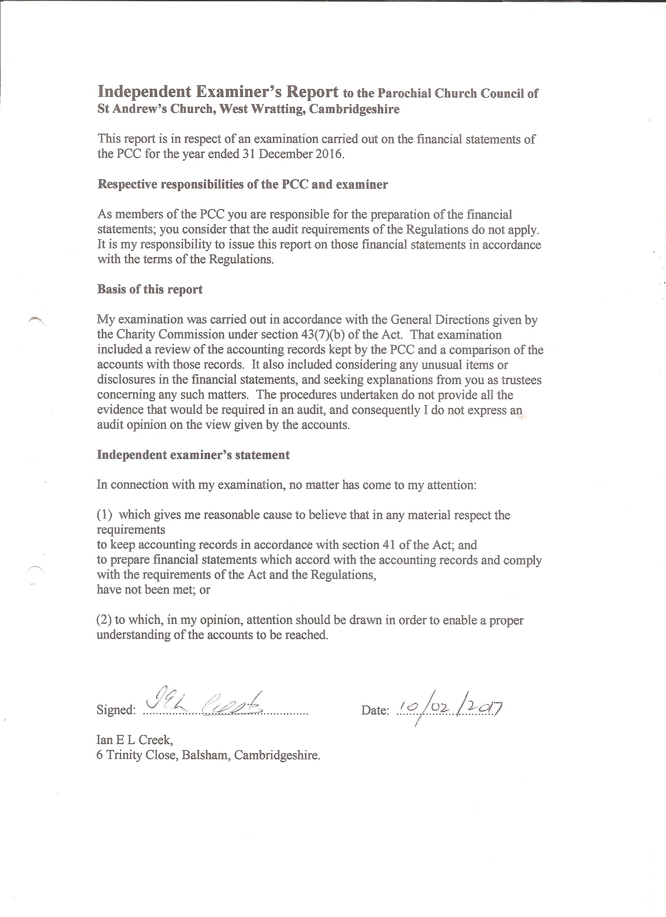

**Proposal to:**

1. **Add disabled access and toilet facilities; and**
2. **Remove the pews at the back of the church and replace with freestanding tables and chairs.**

**Background**

The recent retirement of the local non-stipendiary vicar and the resignation of the priest-in-charge of the benefice has prompted the church wardens to canvass the whole village, including but not limited to the church goers, for their opinions on how St Andrew’s can serve the spiritual needs of a broader section of the community. There is a clear demonstration of a desire to widening the appeal of the church to all residents of West Wratting.

In addition, as part of the Ely 2025 Growth Strategy, we are in the process of developing action plans to address the key "levers of change", which include serving our communities and re-imagining our church buildings. Our growth strategy (Ely 2025) recognises that church buildings continue to draw and inspire people, even those of little or no explicit religious faith.

We recognise that the church plays a vital role in fostering inclusive communities regardless of faith and we’d like to see it as a hub of village life. As well as continuing the existing uses of our church building and grounds (including for bell ringing, annual fetes and Queen’s Birthday celebrations), we are now investigating ways of making the church a more welcoming and versatile space.

We are looking to enhance our visitor experience by adding disability access and a toilet facility. Having both disabled access and a toilet in the church increases the potential for welcoming visitors and the wider community into the building. It is also a useful facility for worshippers! We would like to discuss this possibility at the APCM.

Another possibility that has been suggested and which we would like to raise for discussion at the APCM is to remove the pews at the back of the church to facilitate more flexible use of that area. This would allow a café-style layout that could be adjusted for seating for church services, social events, arts & crafts activities and choral, organ and music practice and fund-raising recitals.

Being able to use the church more flexibly on a regular basis would enhance the ability for outreach within the village community and enable it to continue to be used as a focus for activities on a wider basis. We estimate that the back pews are used between 5 and 10 times per year, but that opening up this space would allow more frequent use of this area.

Most recently in West Wratting, a children's corner has been set up within the church and can be used by our community during daylight hours when our church building is kept open, encouraging greater use as a place of encounter with one another.

The church building is open to all and is not simply a religious building; it is there for anyone who needs time for peace and time for contemplation to sit in, or just to drop in to meet others. The kitchen is used to make tea and coffee or a drink of squash by anyone visiting the church.

**Proposal**

We would like to explore the options for disabled access and a wheelchair-friendly toilet facility with baby-changing facilities. One option is to follow the same route as Hildersham, which has added an attractive extension to the church. There are some photos included at the bottom of this document.

Fundraising for these facilities could start after the church roof has been fixed.

In addition, we have considered all preferences for styles of services and community uses of the church building suggested as part of our church usage consultation process at the end of 2016.

In order to be able to deliver the traditional services that our community has enjoyed, we propose to keep all the existing pews at the front of the church in their current location.

We also recognise that although most of our service space needs are met with the front pews, there will be times where seating is required at the back of the church also. Fold-down chairs will be available to use in such instances.

The layout of the church currently is not considered to be “user friendly”. This proposal would allow flexibility in the use of the back area of the church, whilst maintaining the traditional feel for the front part with existing pews. The back area would become more versatile, welcoming and cosy. This area would be used for discussion groups, prayer meetings, bible study, but also non-religious community gatherings such as coffee mornings, lunches, etc.

Family and child friendly services are a priority to grow our church community through an outreach programme. During the consultation process, it was also suggested that some adults were themselves intimidated by traditional services, especially when it was assumed that they knew the order of prayers and when to stand and sit.

During 2017, we would like to introduce a new type of family-friendly service – the Café Church – that has been a successful format at our sister-church Hildersham for 2 years. We plan to set the church up in cafe style with tables and chairs and serve tea/coffee and cakes or biscuits to begin the service rather than at the end. The service would have a theme that would be introduced at the beginning, include readings to illustrate the theme, followed by an activity which is inclusive for adults and children alike, then some prayers and a closing hymn and blessing. It would be simple and short - about 45 minutes.

The cost of the proposed improvement would be covered by our own resources and specific gifts that will be encouraged for specific items such as chairs, tables and a rug. No changes to the structure of the Building will be required as we remove the 9 pews. This will leave 17 pews in place, as well as the additional seating in the chancel area.

We would like to discuss this proposal at our annual meeting and hope it will find support of the churchgoers and wider community.

**THE ECCLESIASTICAL PARISH OF**

**ST ANDREW’S CHURCH, WEST WRATTING**

**Our community**

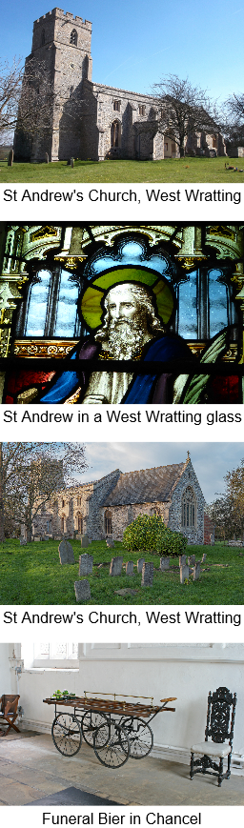West Wratting is a small village of approximately 450 people. The parish is a friendly place, has a strong sense of community, and is welcoming to newcomers. The housing is mainly concentrated along the High Street and Mill Road, but a number of households live on The Common, the road between Withersfield and West Wratting. The village is surrounded by agricultural land and farm estates and there are many attractive walks in the area. Residents commute to Cambridge (and its university, hospitals and science parks), Newmarket, Saffron Walden, and London to work.

The village has a pub, The Chestnut Tree, which is a focus for much regular social activity including a book group, over sixties meetings, and a third Thursday lunch. The landlords are very supportive of village events. There is a Village Hall, which was extensively refurbished to mark the Millennium and is well equipped with a kitchen, bar, stage and other facilities. It is overseen and managed by a committee and hosts a range of activities, including exercise and dance classes. It is also the venue for a Café which is held on the first Saturday of each month and run by a group of volunteers. This serves coffee and cake and provides a popular forum for conversation and social exchange. There is also a recreation ground, which is the base for a youth football club and the D’Abo tennis club. West Wratting has an annual Progressive Supper, which is an enjoyable opportunity to meet new people and share a meal together. The village is also in the vicinity of a former World War II RAF Bomber Command site (Wratting Common) and there is a yearly service on Remembrance Day there.

Regular fund raising events for the church include a Pet and Produce Show (including a dog show and a teddy bear parachute drop from the tower) in early August; a clay-shooting day in late August; a Harvest Supper in September; and an annual Autumn Concert in October (normally held in Balsham church). The church and churchyard have also been at the centre of village celebrations, including parties to mark the recent Queen’s 90th Birthday and Jubilee anniversaries.

The parishes of West Wratting and Weston Colville Fund have a magazine, the *Challenge*, which is published monthly. The village also has its own website.

**Our worship**

The morning service (normally said Eucharist) is currently held at 10.45. We use a red service book based on Common Worship and using contemporary language. Hymns are sung with organ accompaniment. There are four well attended family-friendly Songs of Praise services per year at 4pm on Sunday. These are organised by John and Scilla Harvey, who bring musicians and singers from outside the village to enliven the service. Drinks and refreshments follow. There is a carol service and Christingle service for children. West Wratting and Weston 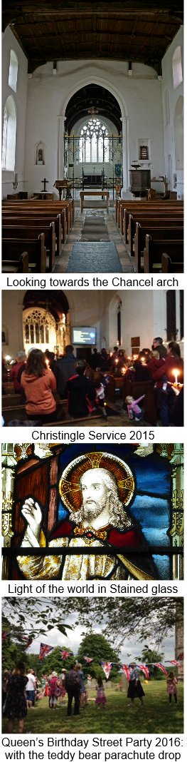Colville have joint services at Christmas, alternating as the location for midnight mass and Christmas morning from year to year. On the fifth Sunday, there is a united benefice service, which takes place by rotation in one church in the benefice.

**Our mission**

St Andrew’s has a small but committed congregation, which we are keen to see grow. There are many inhabitants of West Wratting who already contribute to supporting the life of the church as a community and building without attending services. We are eager to encourage and strengthen ties with the rest of the community through events and initiatives that bring together church goers and non-church goers. We want to make St Andrew’s increasingly inclusive. We strongly support the Parish Nurse Project, which we regard as central to creating a caring and compassionate community.

Members of the congregation would like to see existing services maintained, but we also hope to introduce different styles of service to meet the needs of a wider range of people within the community, notably families with children, who find the traditional liturgy intimidating. We want the church to embrace all age and social groups (including disabled people) and strengths of belief. This may involve a creative reconfiguration and use of the church space, and in particular the chancel. We are also keen to reinstate a monthly Family Service and some would like to see the introduction of evening and Sunday afternoon discussions. We would be open to the church being used for services by other denominations. We hope that the new incumbent will help us to engage in outreach initiatives to assist the church to grow.

**Our structure**

We have two churchwardens (Sebastian Bain and Alex Walsham) and an electoral roll of 35**.** There are six members of the PCC (including the churchwardens) and they meet five times a year. We have a rota of laypeople for the setting up of the service and serving coffee afterwards, as well as for cleaning and flower arranging. We have an organist who supports all our services. We have an active group of bell-ringers, who ring each Sunday, led by the tower captain, Dr Mike Rowland.

**Our building**

The oldest part of the church dates from the fourteenth century and changes were made in the fifteenth century. The church was heavily restored in the eighteenth century and further remodelling took place in the nineteenth century. The church has a fine ironwork screen that dates from 1922. The organ was built in 1895 and enlarged in 1953, when it was moved to its present position. It was recently repaired with the assistance of a grant from the Wadlow Wind Farm Community Fund. The Church has six bells. The church seats 120 in the pews, but can seat up to about 250 if chairs are put out in the chancel and other areas. The church has an oil-fired heating system. There is 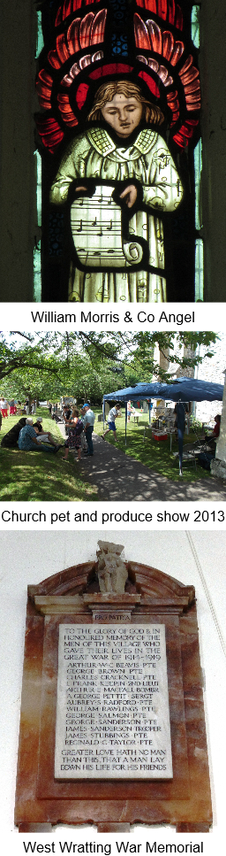a kitchen in the area under the tower.

In April 2016, St Andrew’s was the victim of the theft of two thirds of its roof lead. This catalysed a vigorous fund raising campaign to replace the roof with steel led by the PCC and assisted by other villagers, who have been immensely generous with their time and support. Our misfortune has been reported in local newspapers and also featured on ITV Anglia news. We have secured grants from a number of charitable trusts and benefited from generous donations from local people. Happily, the works to repair the roof and the damage to the interior are now underway. These began in January 2017 and will be followed by redecoration of the nave and chancel. The last Quinquennial inspection took place in October 2016 and revealed no serious issues requiring urgent attention, once the roof repair is complete. We also have plans to improve disabled access to the church and to install a toilet to enable the building to be used for a variety of purposes by the whole community.

A team of volunteers, led by Cobby McCall, keeps the churchyard in excellent order. The grass is regularly mown and there is a twice yearly working party to prune trees, remove ivy, and tidy gravestones, accompanied by coffee and doughnuts. Burials still take place in the churchyard.

A recent meeting to which the whole village was invited elicited some excellent ideas for utilising the building and churchyard for other activities, including flower arranging courses, a community orchard, farmers’ market, remembrance garden, youth groups, camping, cooking and wildlife classes, and a mini sports day.

The Vicarage in West Wratting was built in 1971 and has been used as a residence for the House for Duty Priest in the past. It is currently occupied by tenants.